D. Documents Collection

This section provides an assortment of historical document blanks that you can remove from the binder and reproduce as needed. The selection of Union and Confederate Navy paperwork is based simply on what was available at the time of writing. The majority of the forms are recreations based on actual period samples; where the sample came from the “other” side, this is indicated and no claim is made to its use on both sides. Additionally, there are a number of forms that have proven useful in “enlisting” children or running a living history camp; these are plainly indicated as “not authentic.” Most forms were necessarily scaled down to allow for the binding in this book; each therefore carries an indication of the percentage by which it should be enlarged to be returned to its authentic size.

If you have authentic paperwork that is not represented here, but that you believe would be useful to the naval living history community, please contact the USNLP at email@usnlp.org and we’ll include it in the next revision to this edition.

(Note on deck logs: the fastidiousness with which these were filled out varied by ship and by watch officer. Even within the same squadron or small flotilla, one ship might record barometric pressures, another wind direction, and a third record the temperature and amount of fresh water on hand. Events of note could be limited to a single line or appear in copious detail.

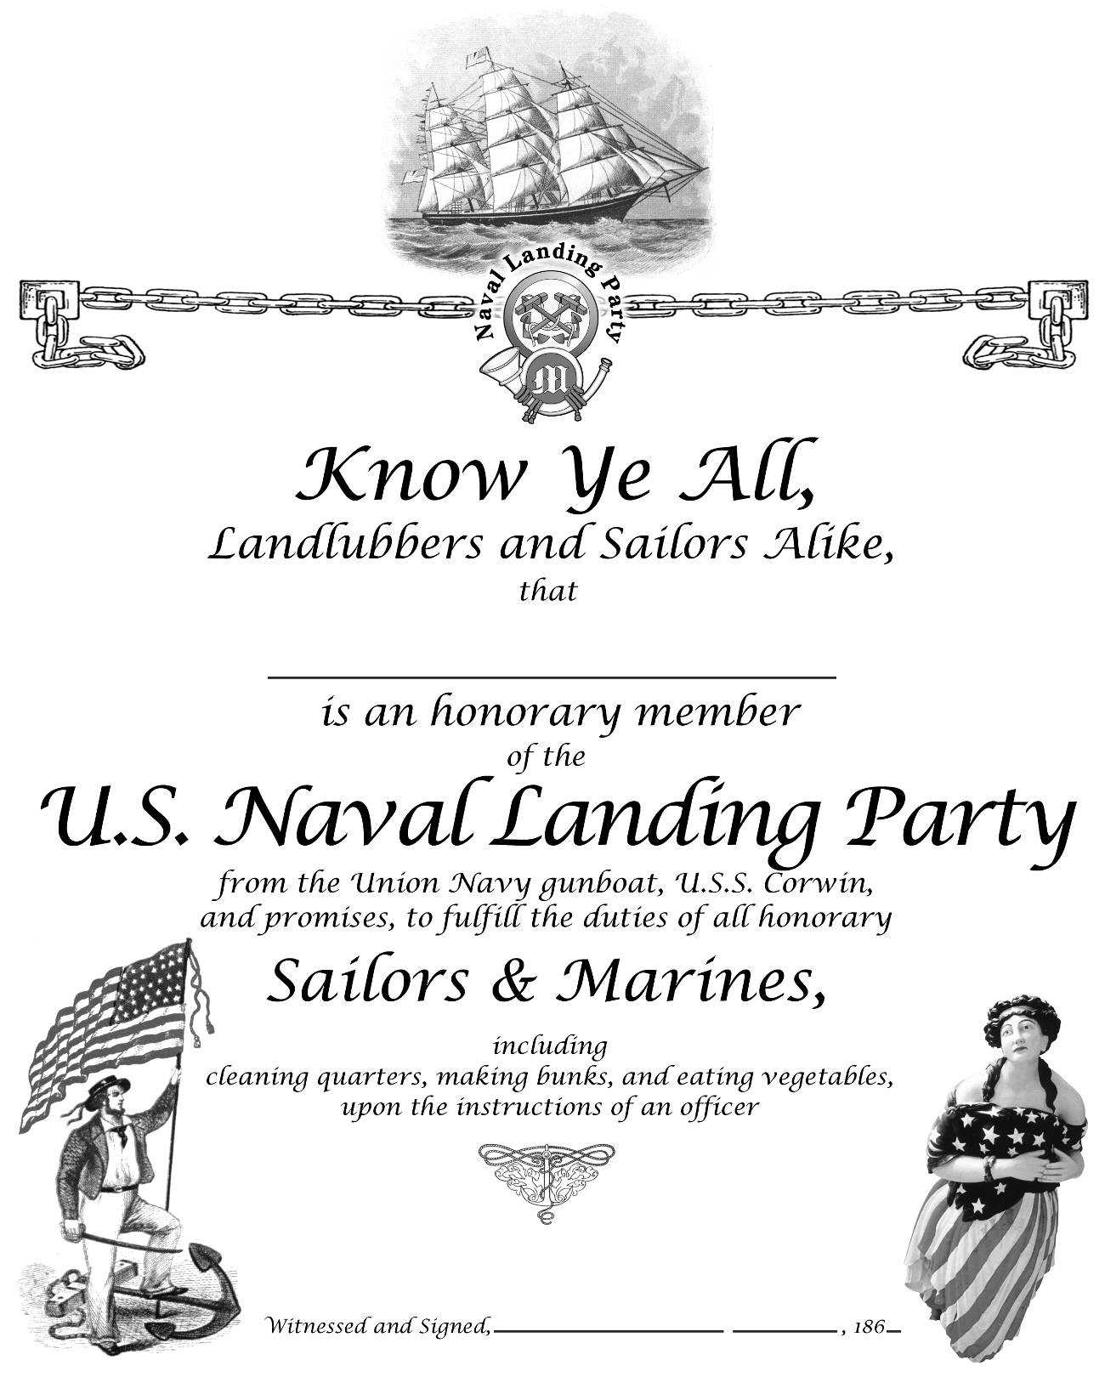

Note: This is not an authentic form.
Enlarge by 135% to fill an 8-1/2 x 11 sheet of parchment.
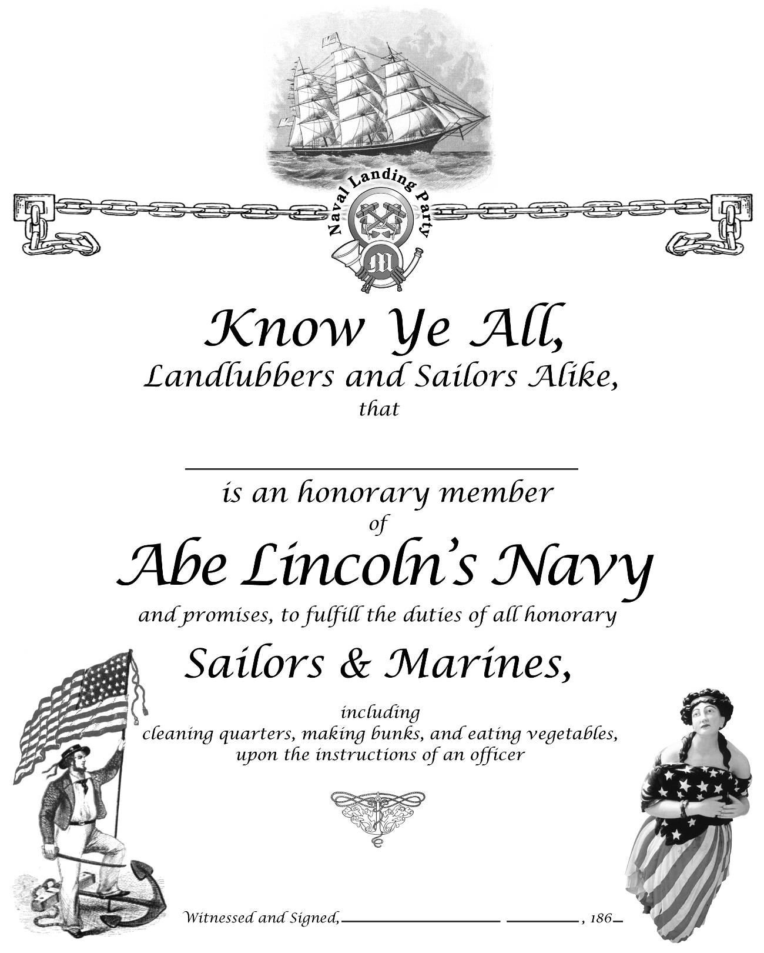

Note: This is not an authentic form
Enlarge by 135% to fill an 8-1/2 x 11 sheet of parchment..
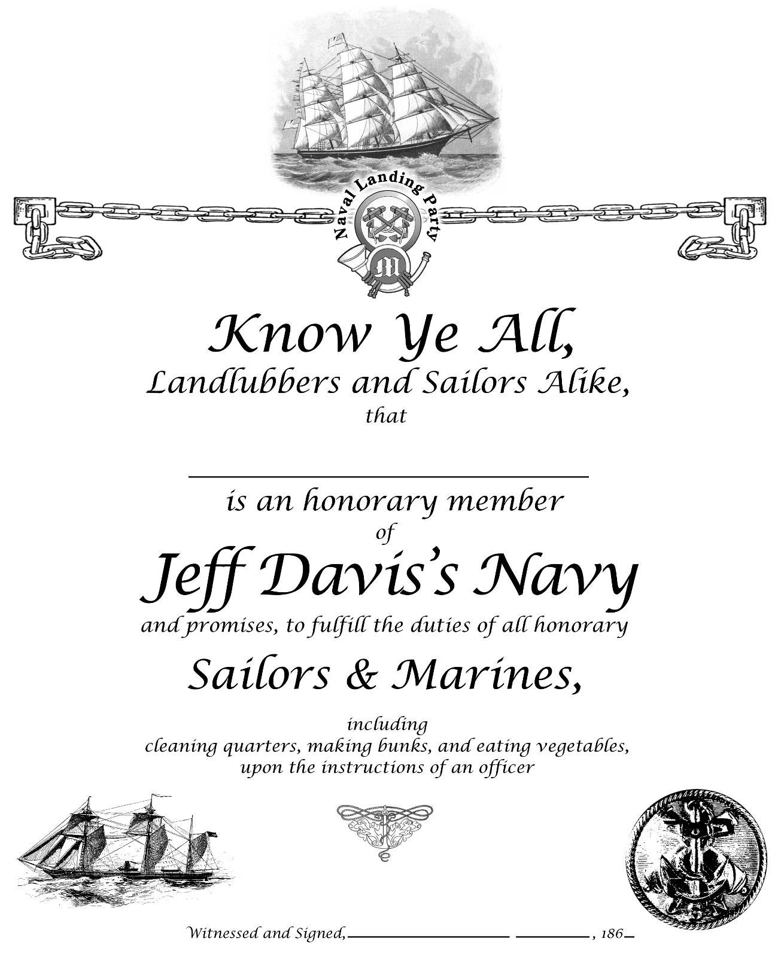

Note: This is not an authentic form
Enlarge by 135% to fill an 8-1/2 x 11 sheet of parchment.
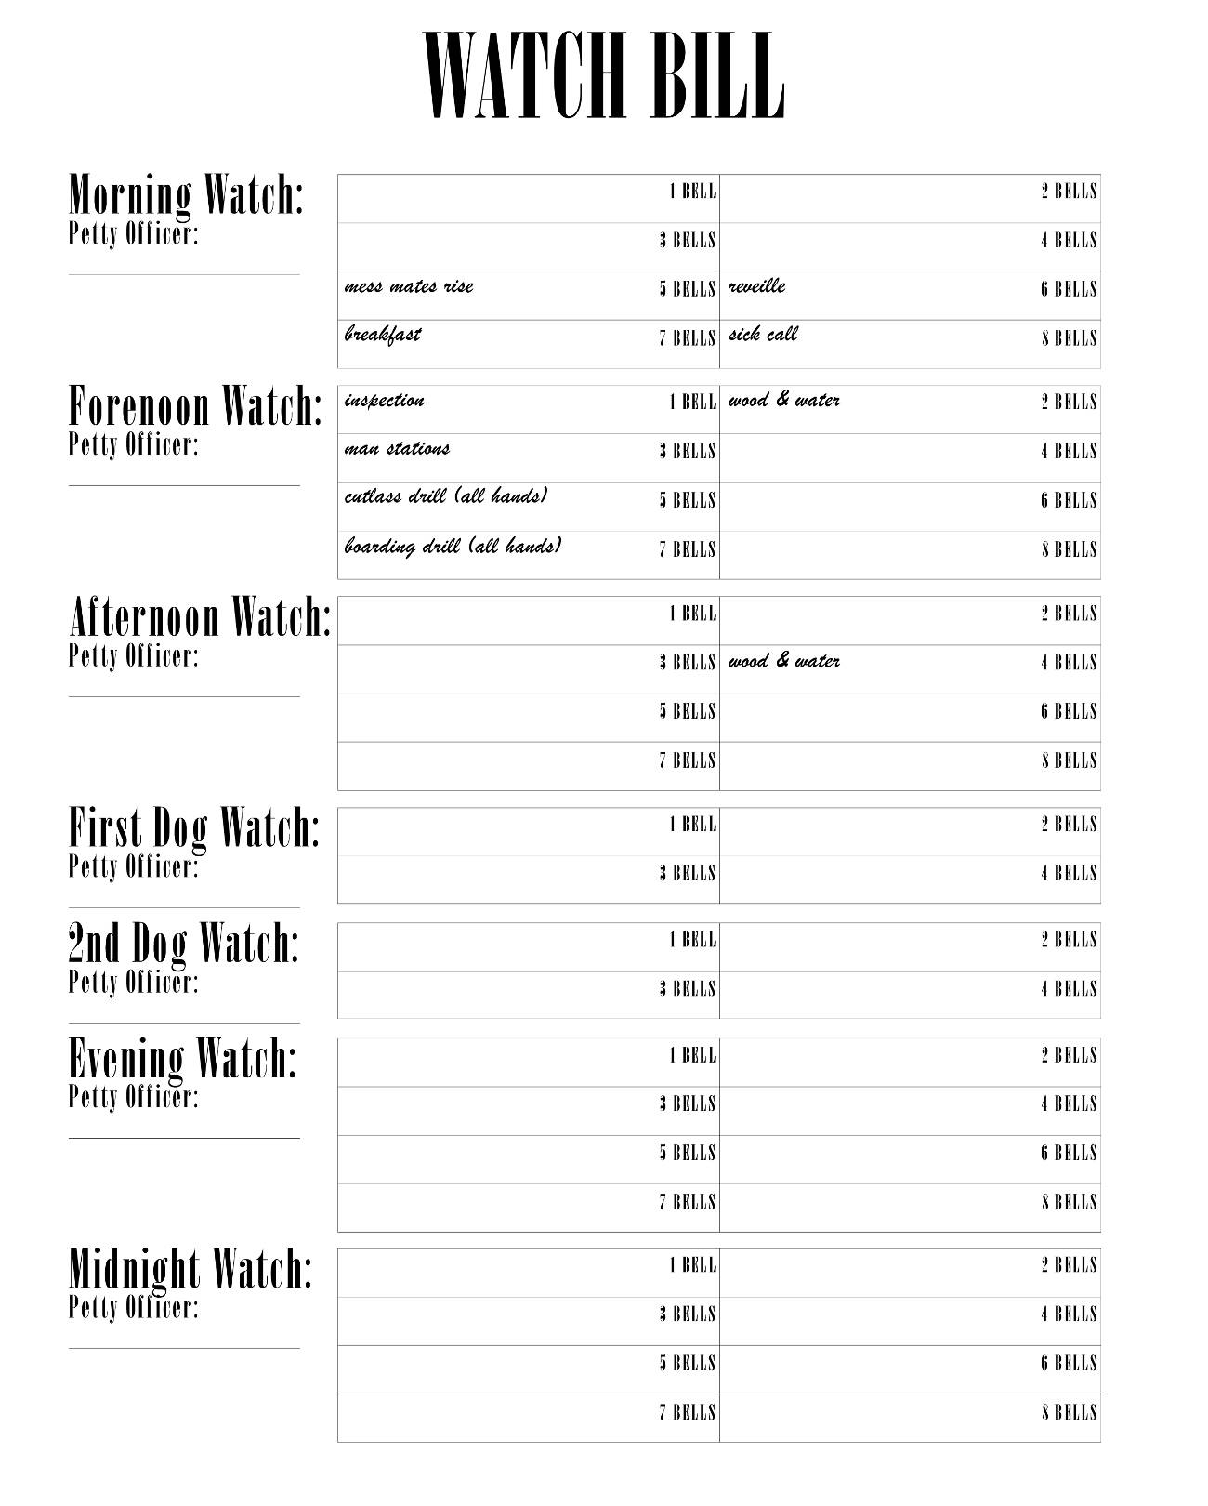

Note: This is not an authentic form.
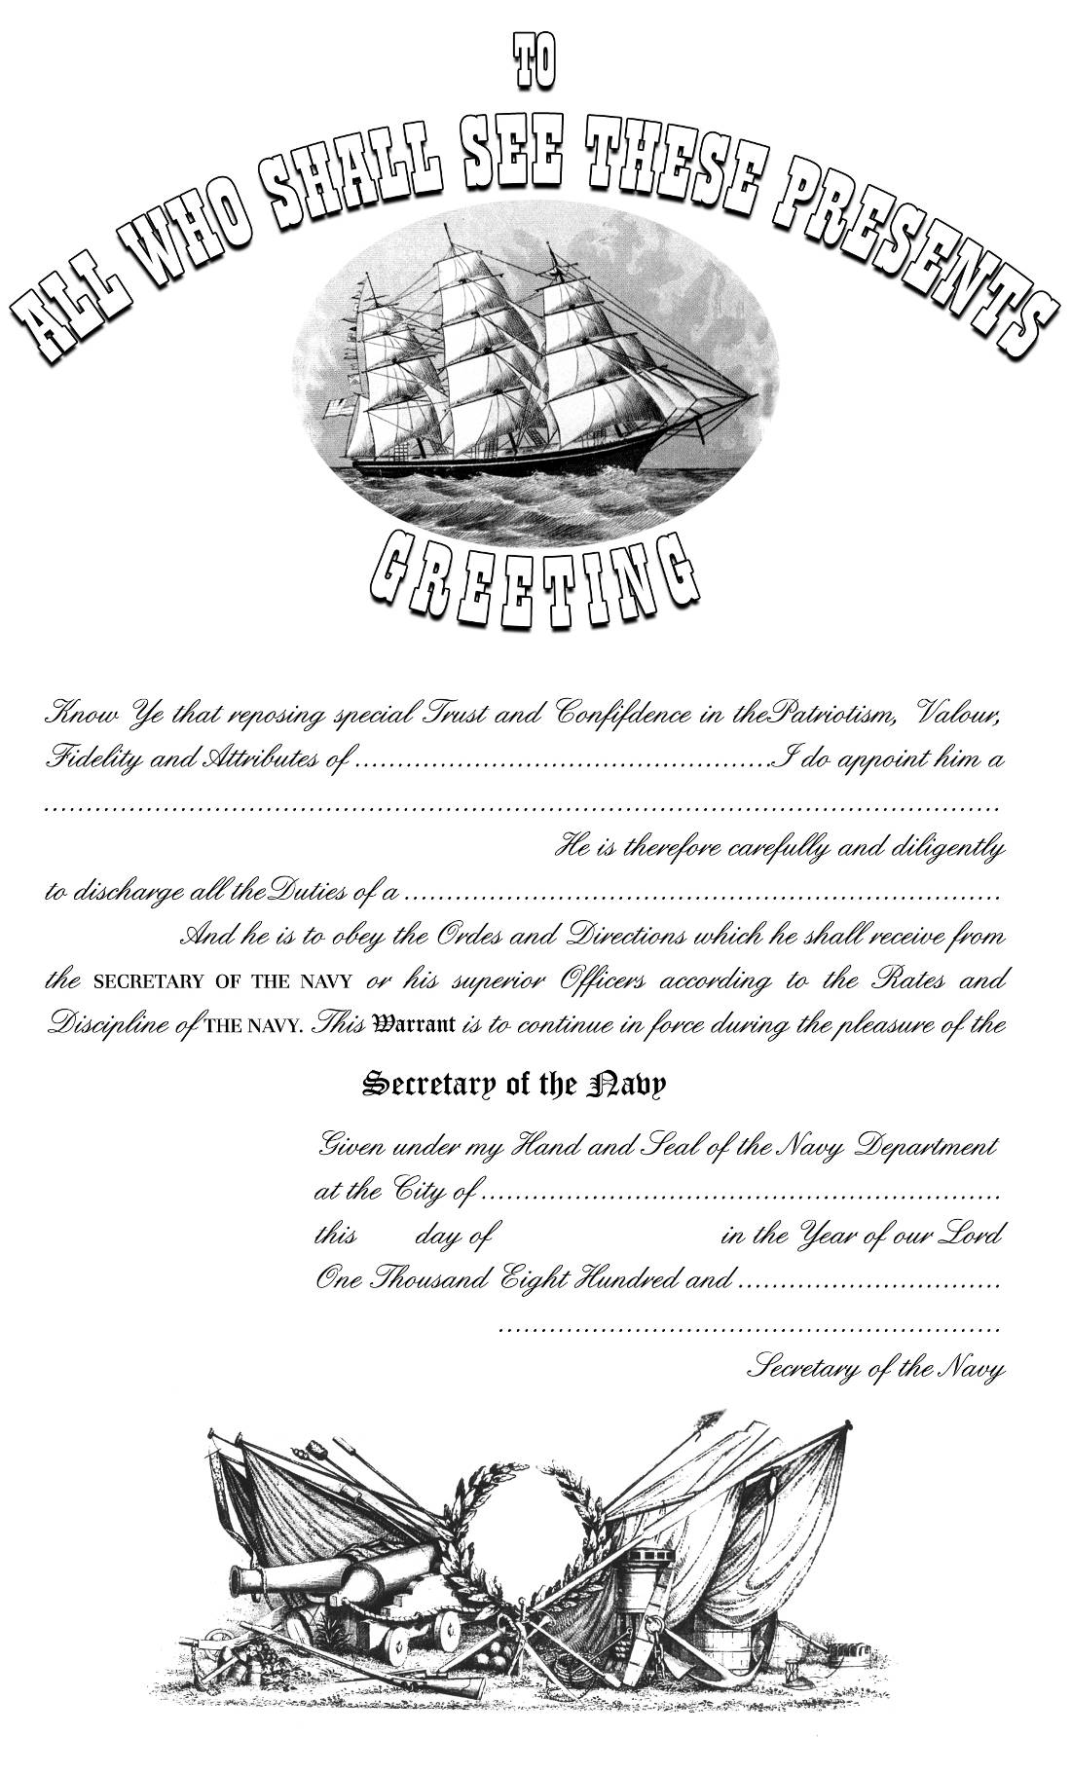

USN warrant
Scale to 112%
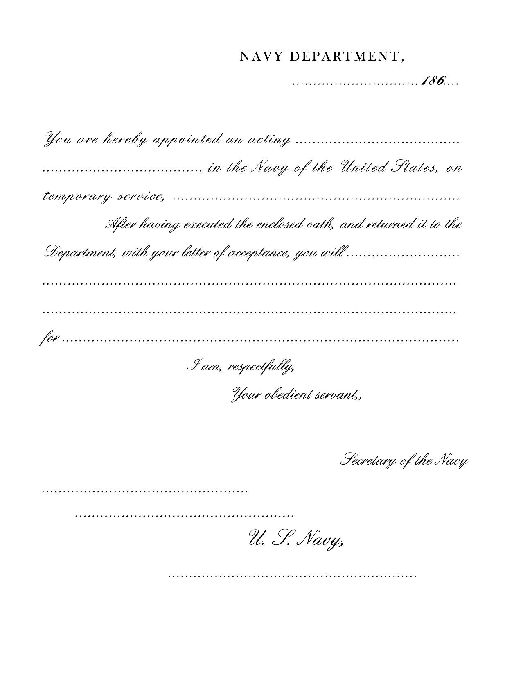

USN acting commission
Scale to 120%

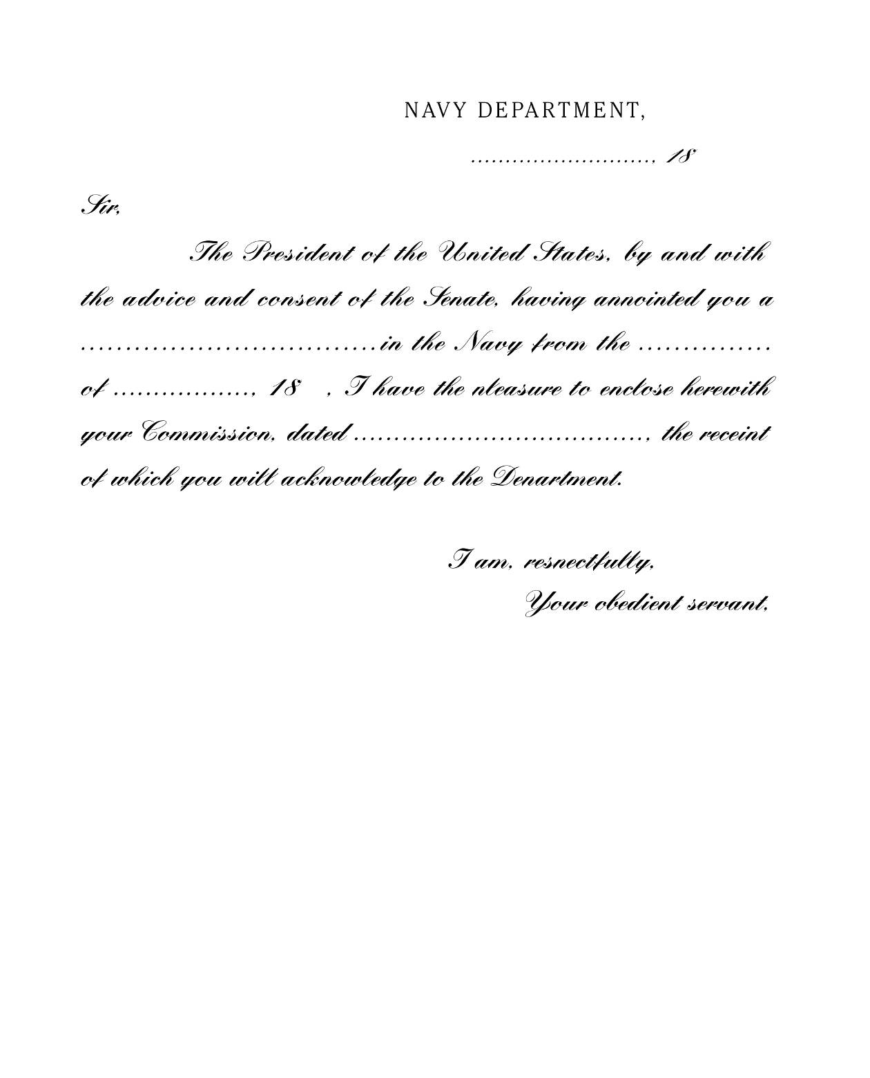

Cover letter to accompany a USN officer’s commission
Actual size
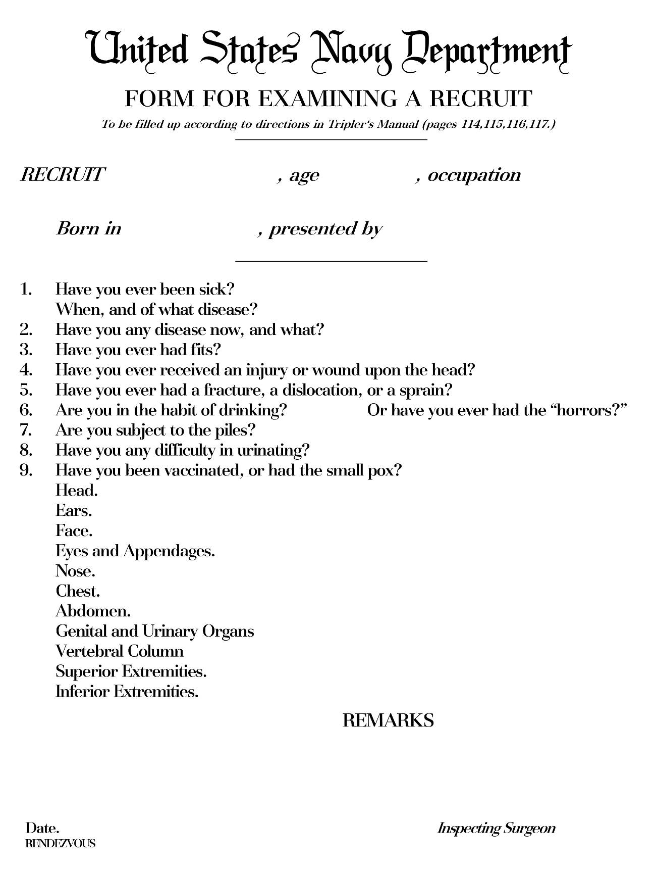

Medical questionnaire for Union Navy recruit
Scale to 120%
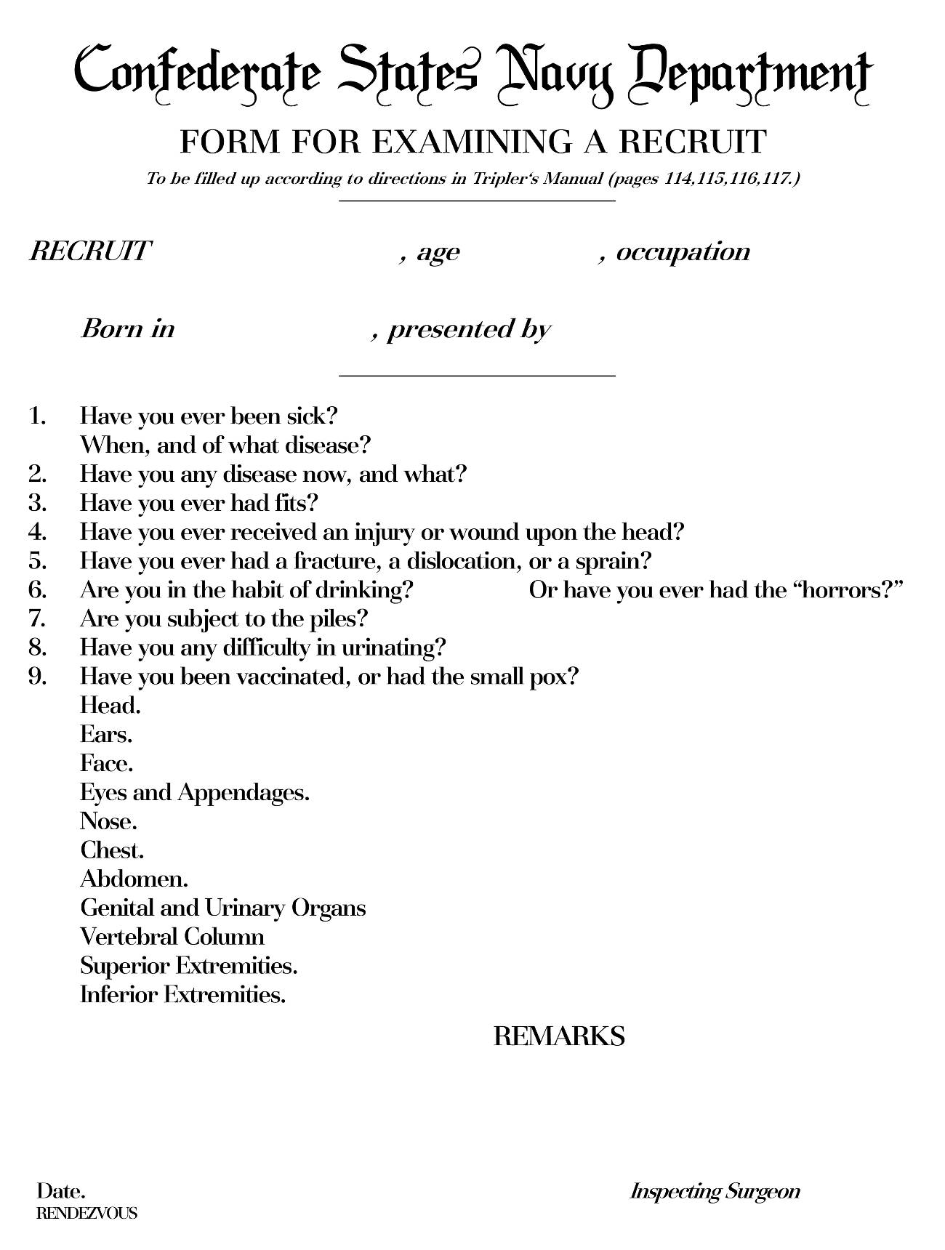

Medical questionnaire for Confederate Navy recruit
Scale to 120%
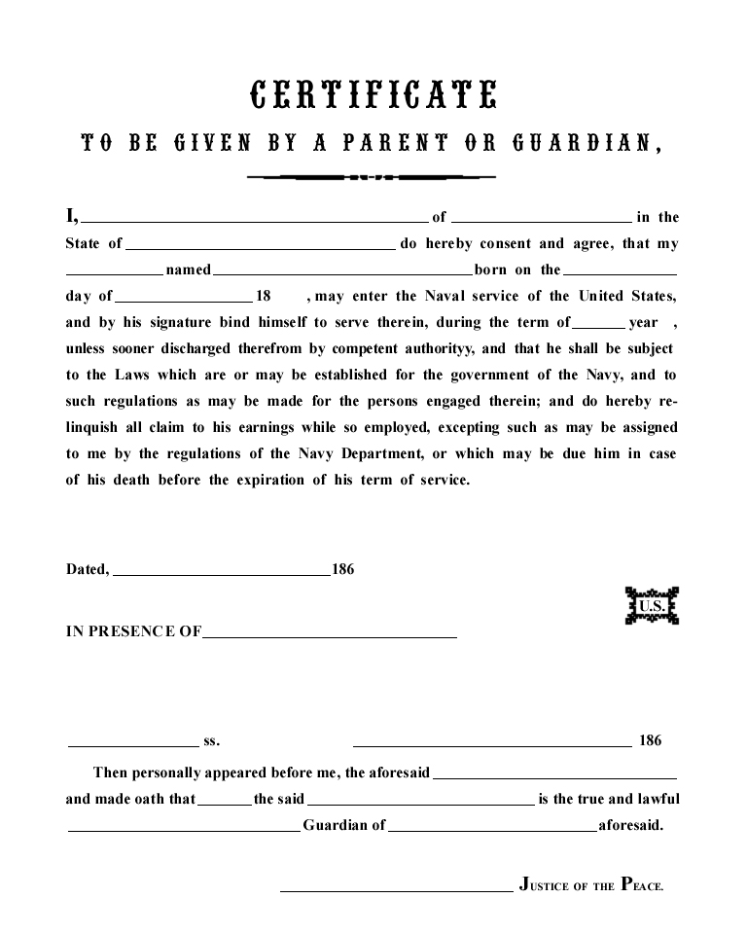

Parental consent form for underage USN recruit
Scale to 120%
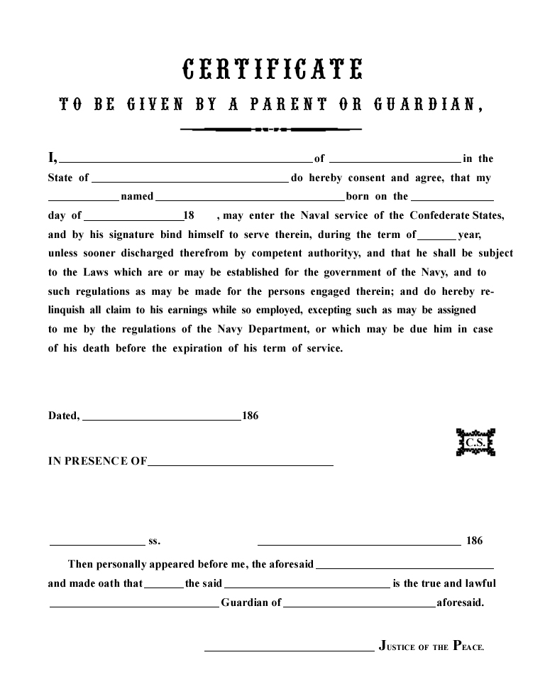

Parental consent form for underage CSN recruit
Scale to 120%
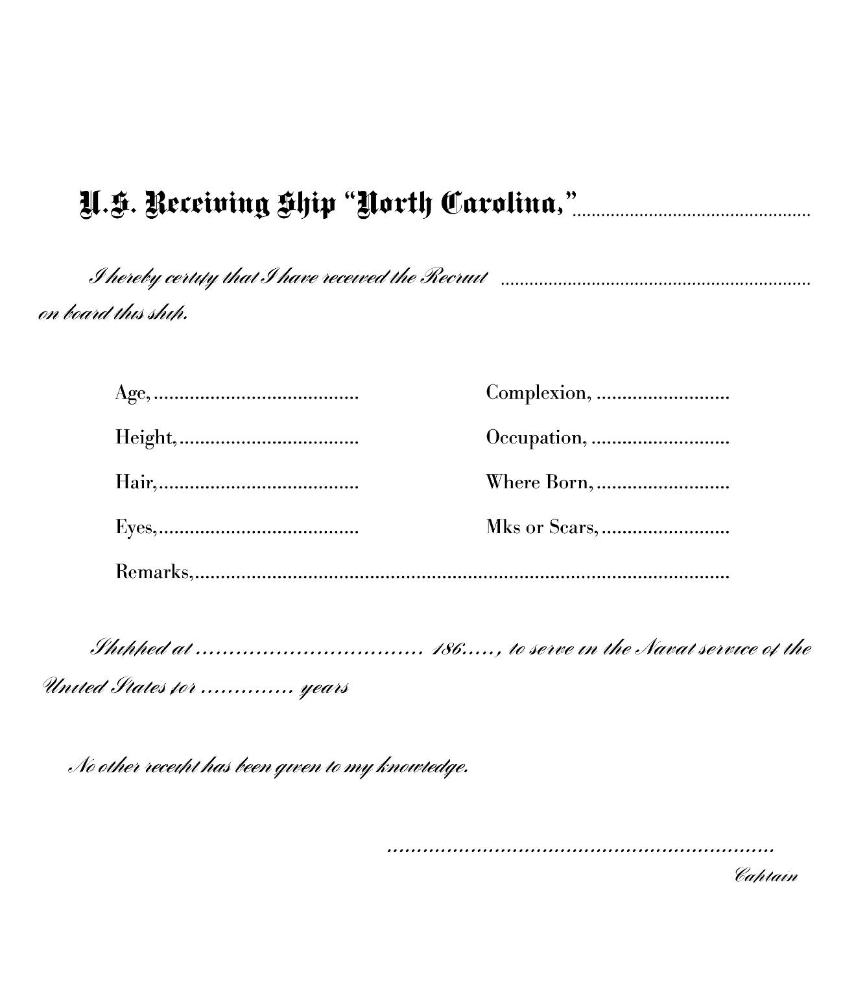

Recruit receipt form, receiving ship USS North Carolina
Scale to 117%

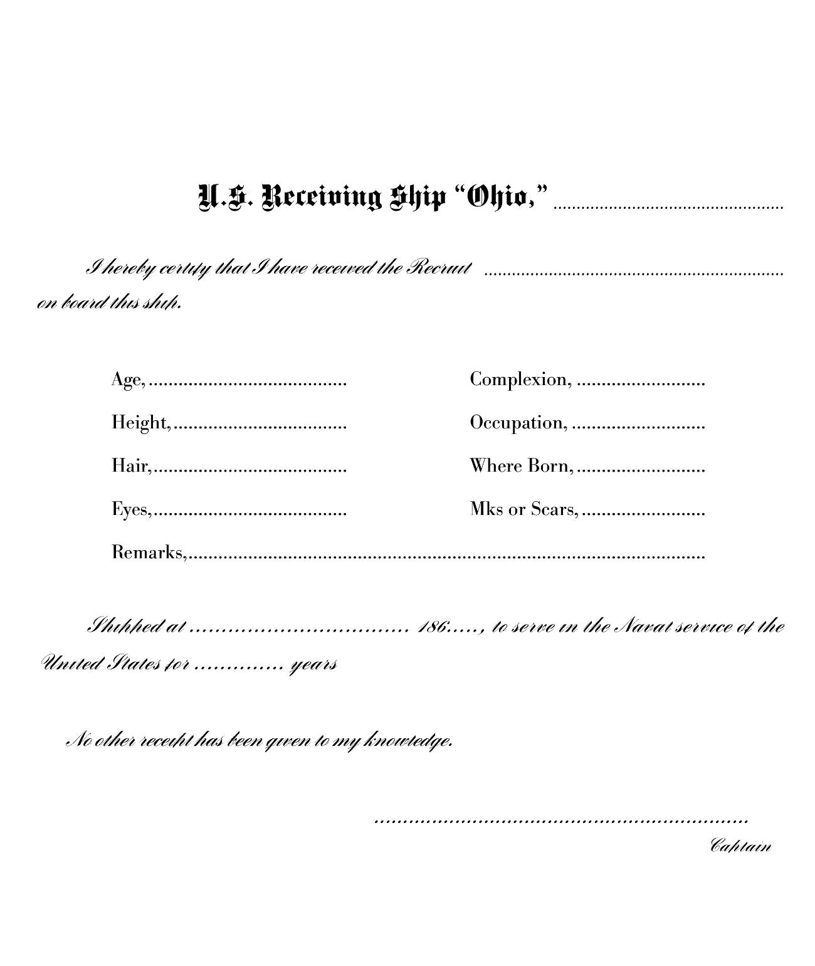

Recruit receipt form, receiving ship USS Ohio
Scale to 117%

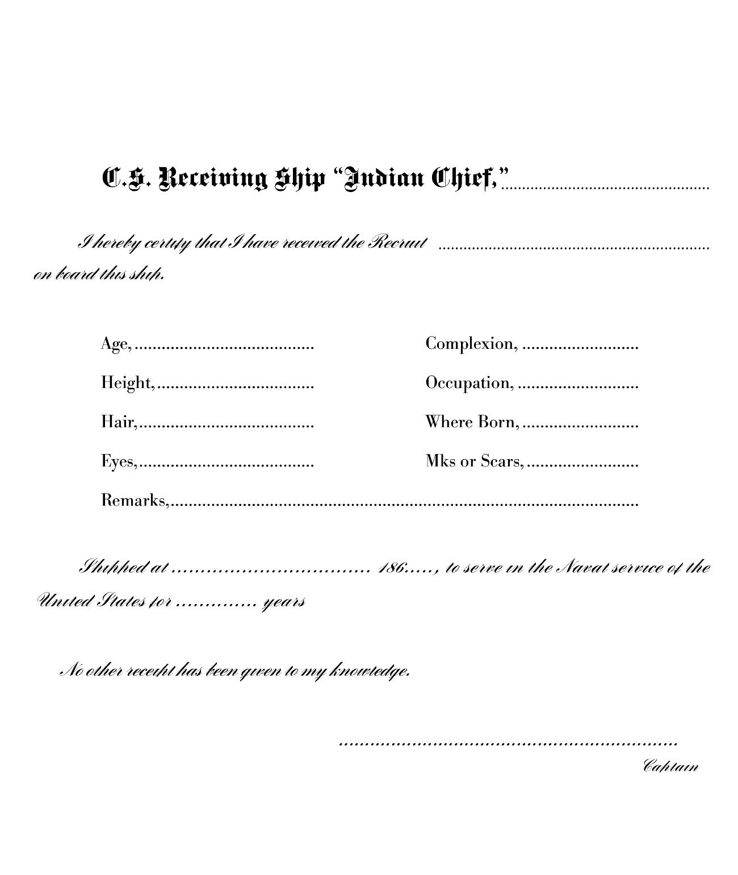

Recruit receipt form, receiving ship CSS Indian Chief
(based on USN form)
Scale to 117%

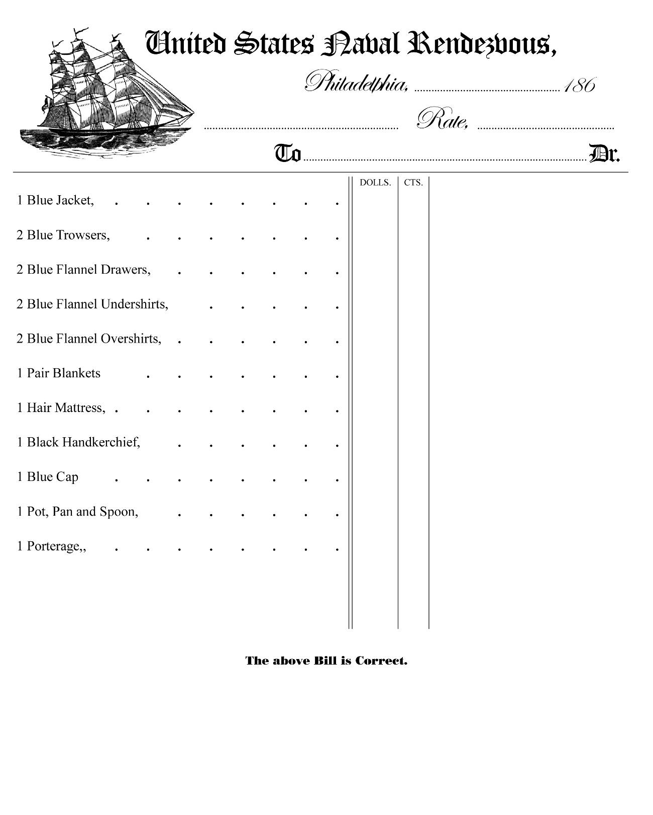

Receipt for issue at rendezvous
Scale to 122%
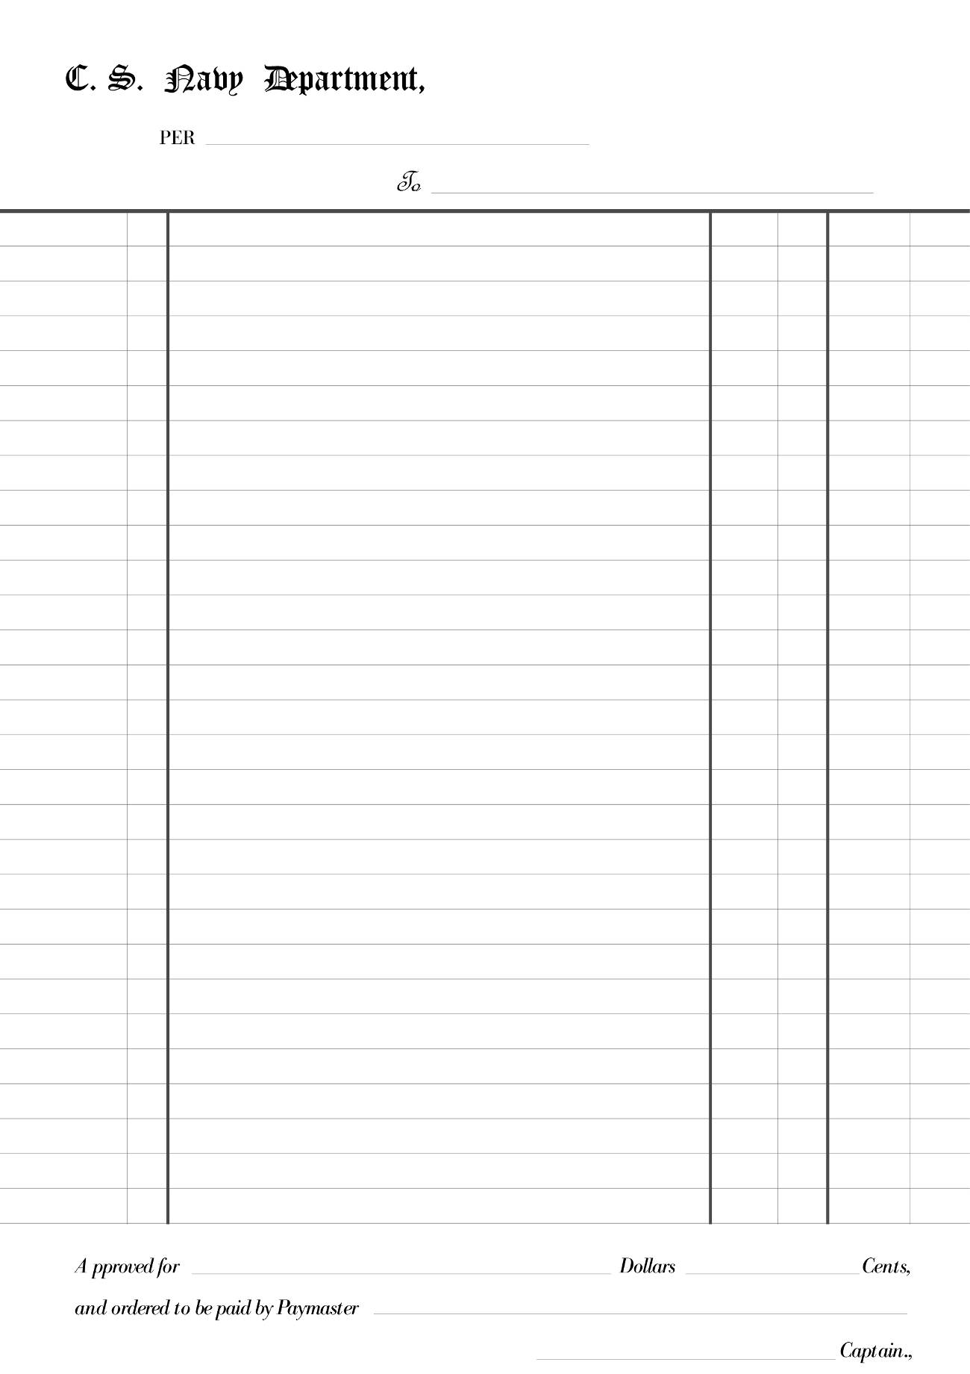
Accounting form, CSN (based on USN form), actual size
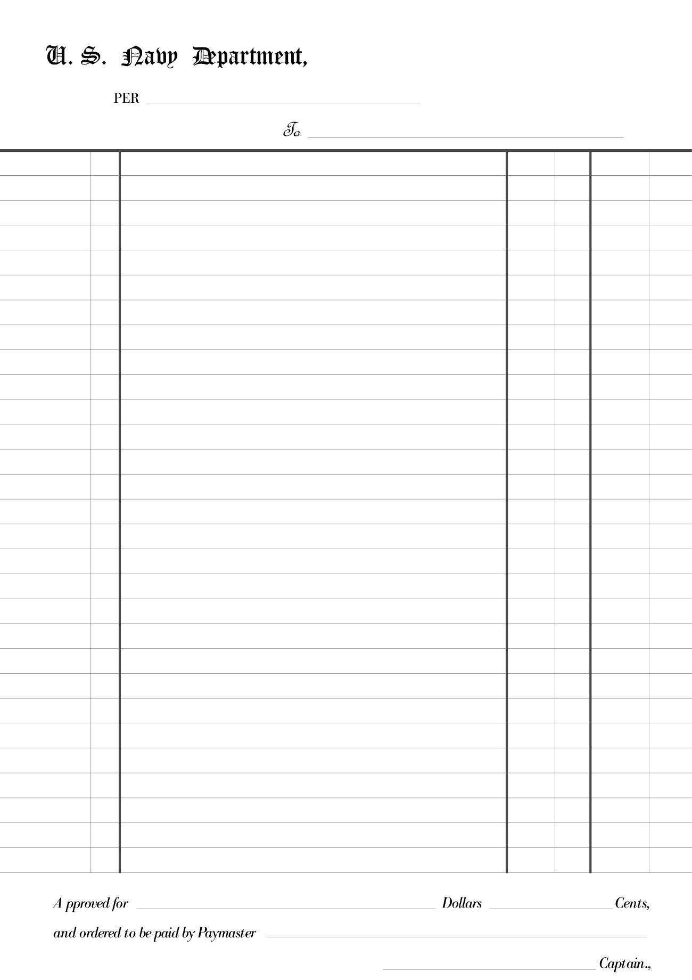

Accounting form, USN, actual size
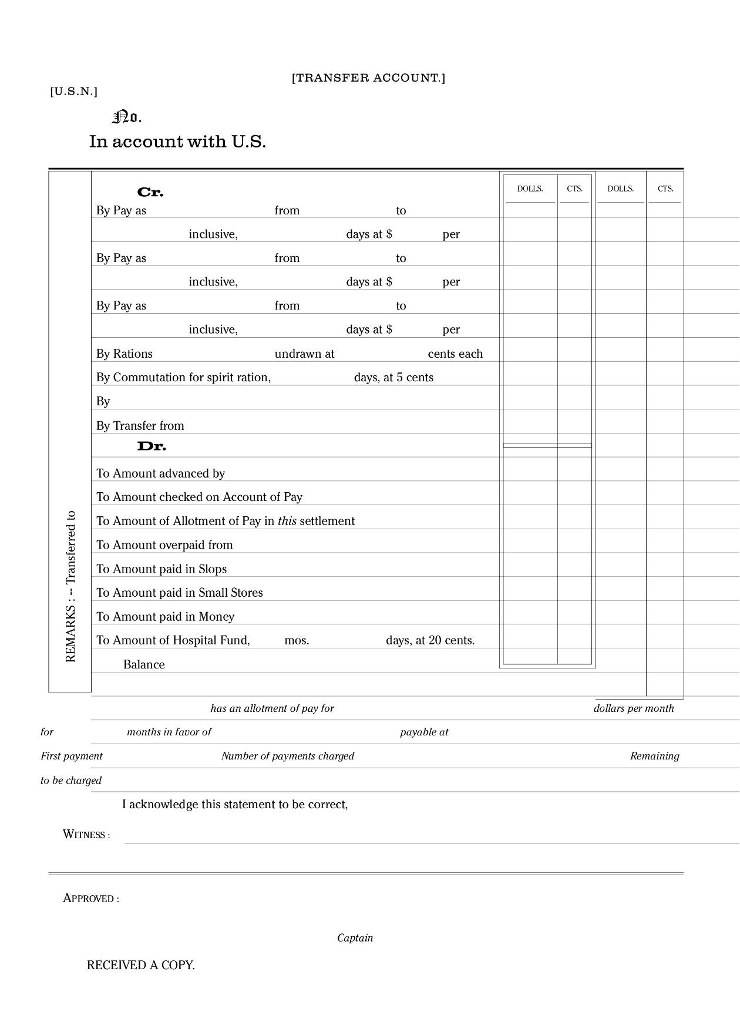

Transfer of account, USN
Actual size
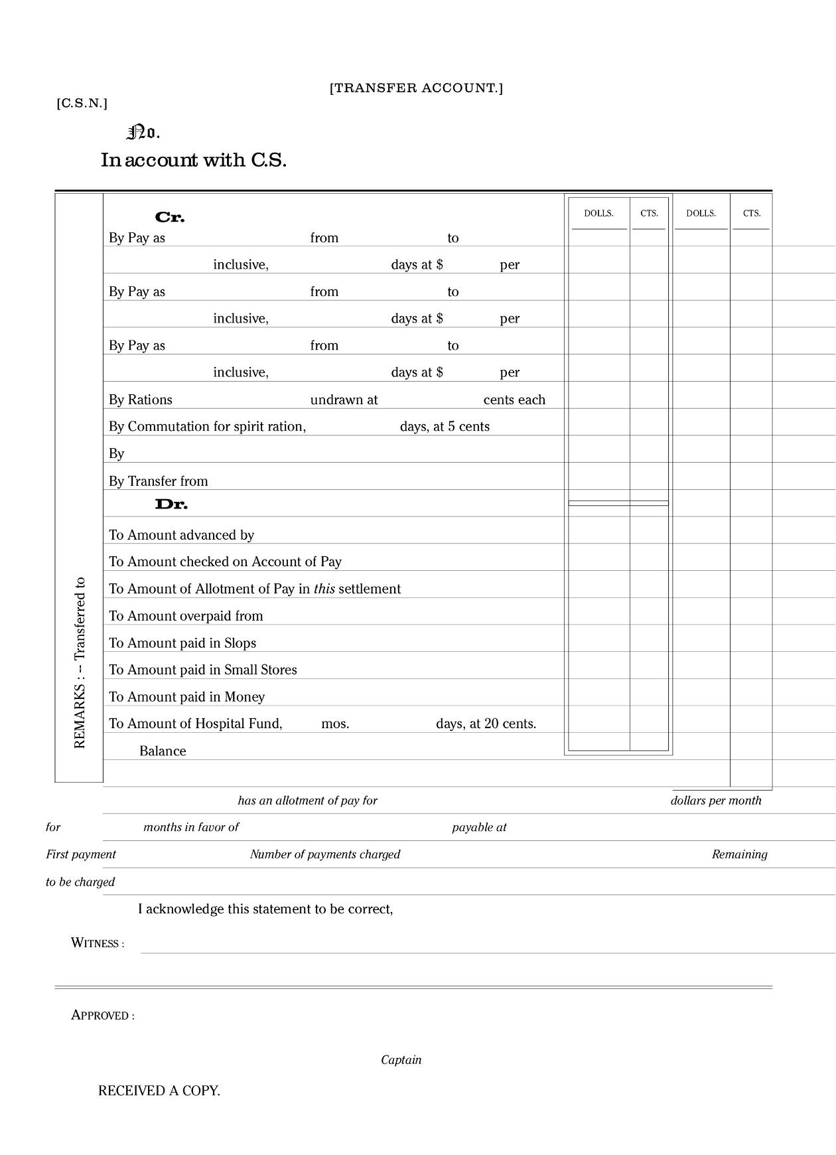

Transfer of account, CSN
(based on USN form)
Actual size
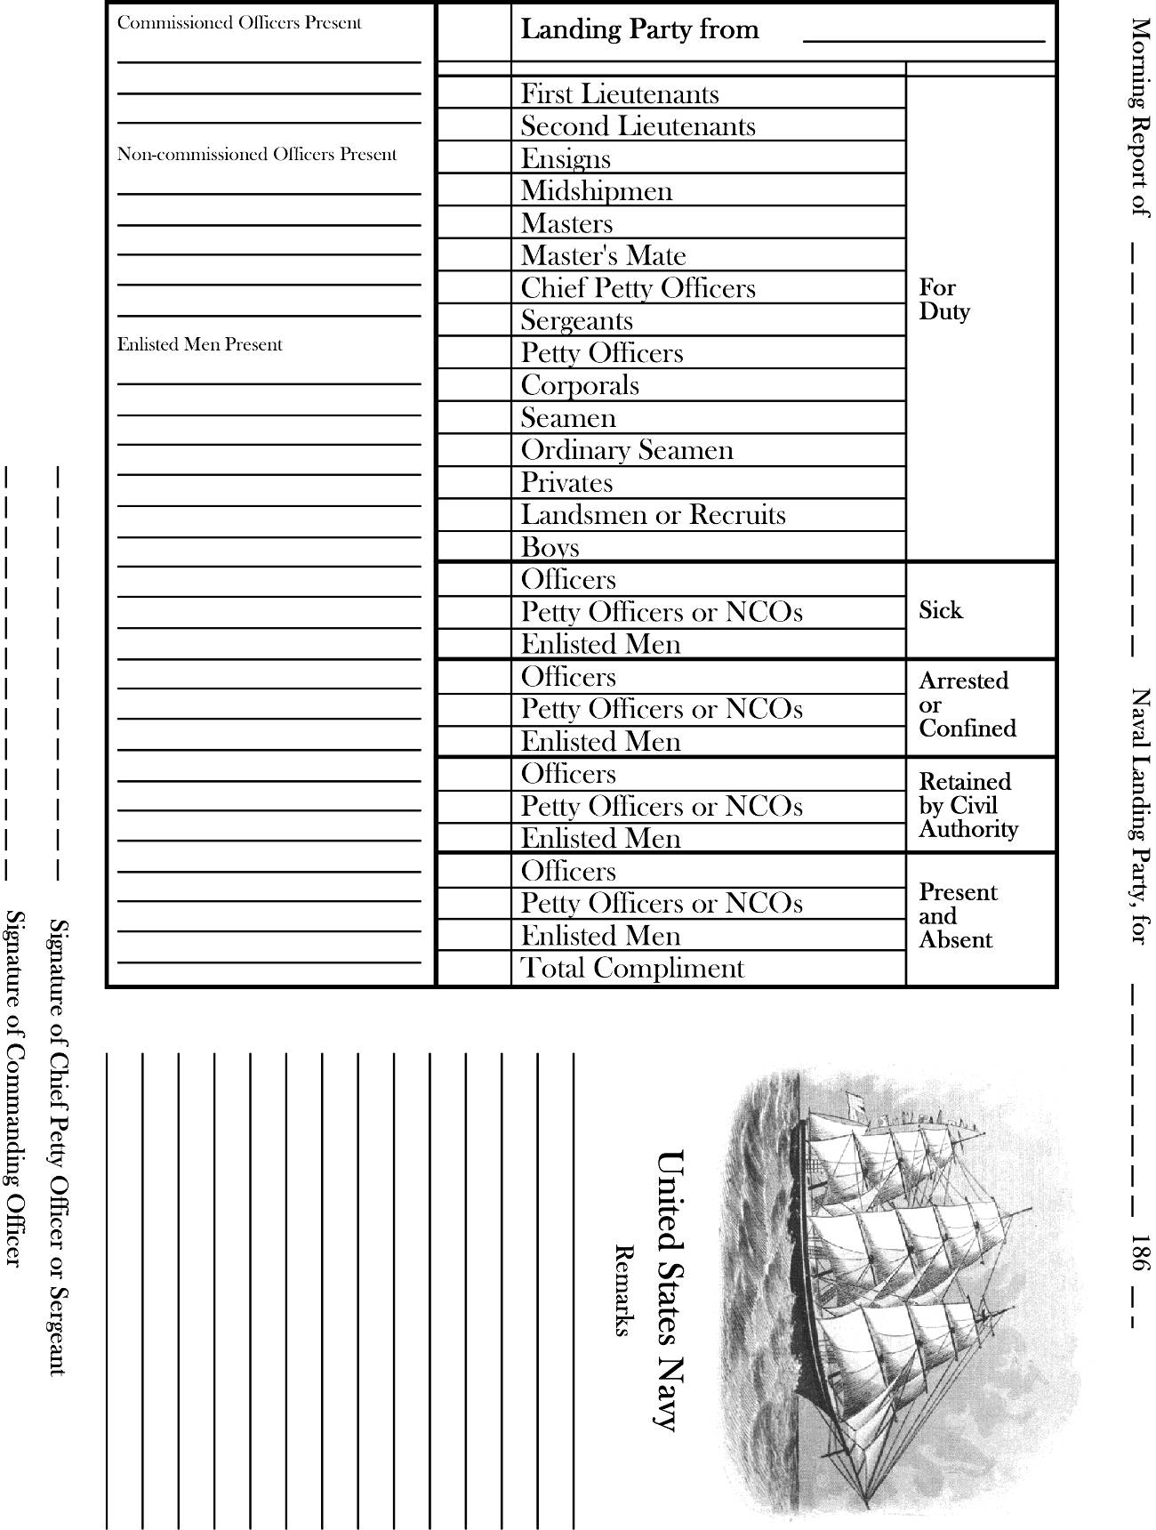

Morning Report, USN (usually required at reenactments)
Note: This is not an authentic form
Scale to 115%
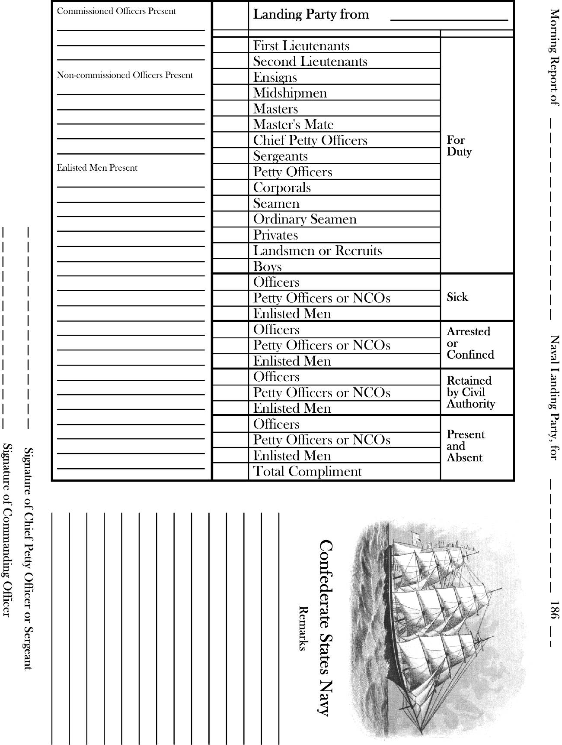
Morning Report, CSN (usually required at reenactments)
Note: This is not an authentic form
Scale to 115%
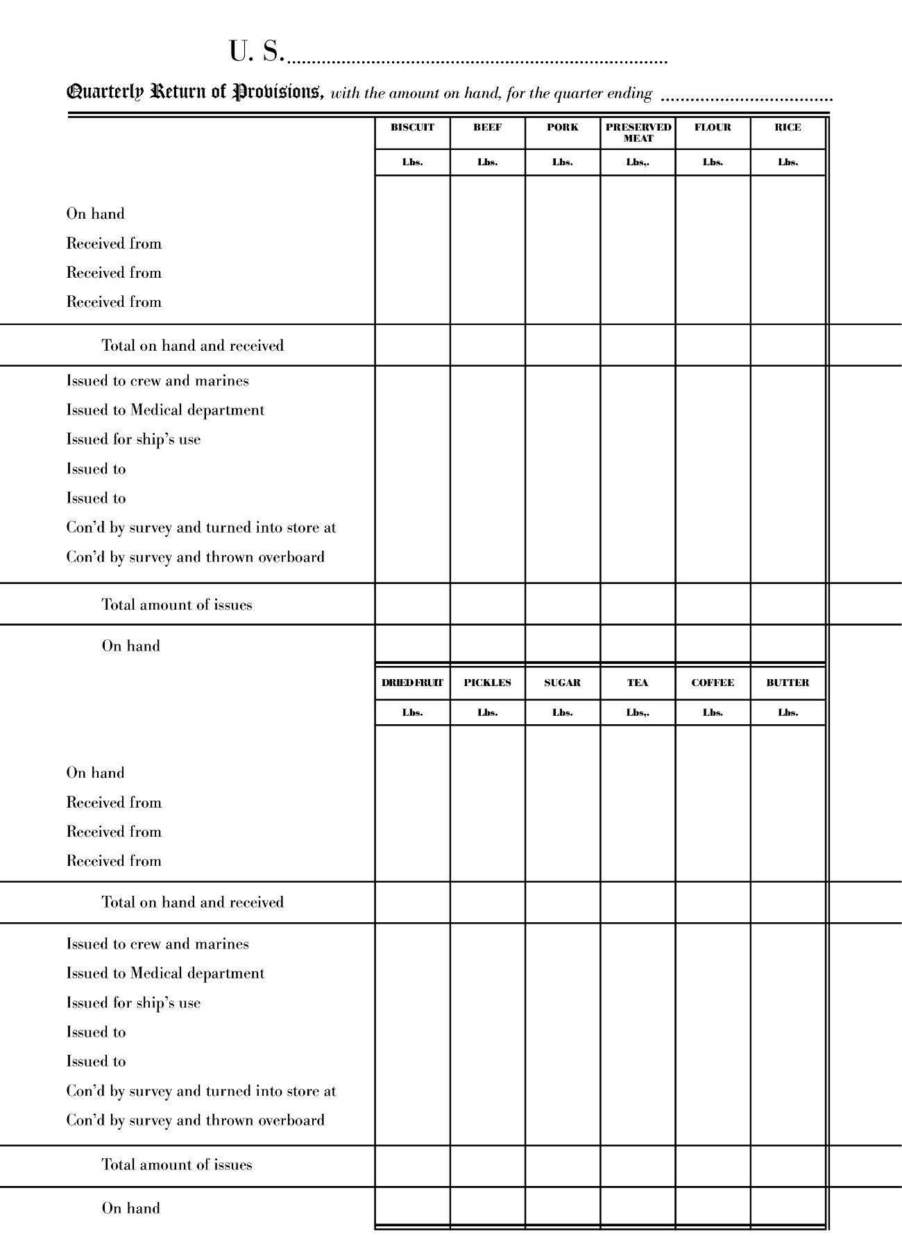

Quarterly return of provisions, USN
Scale to 112%
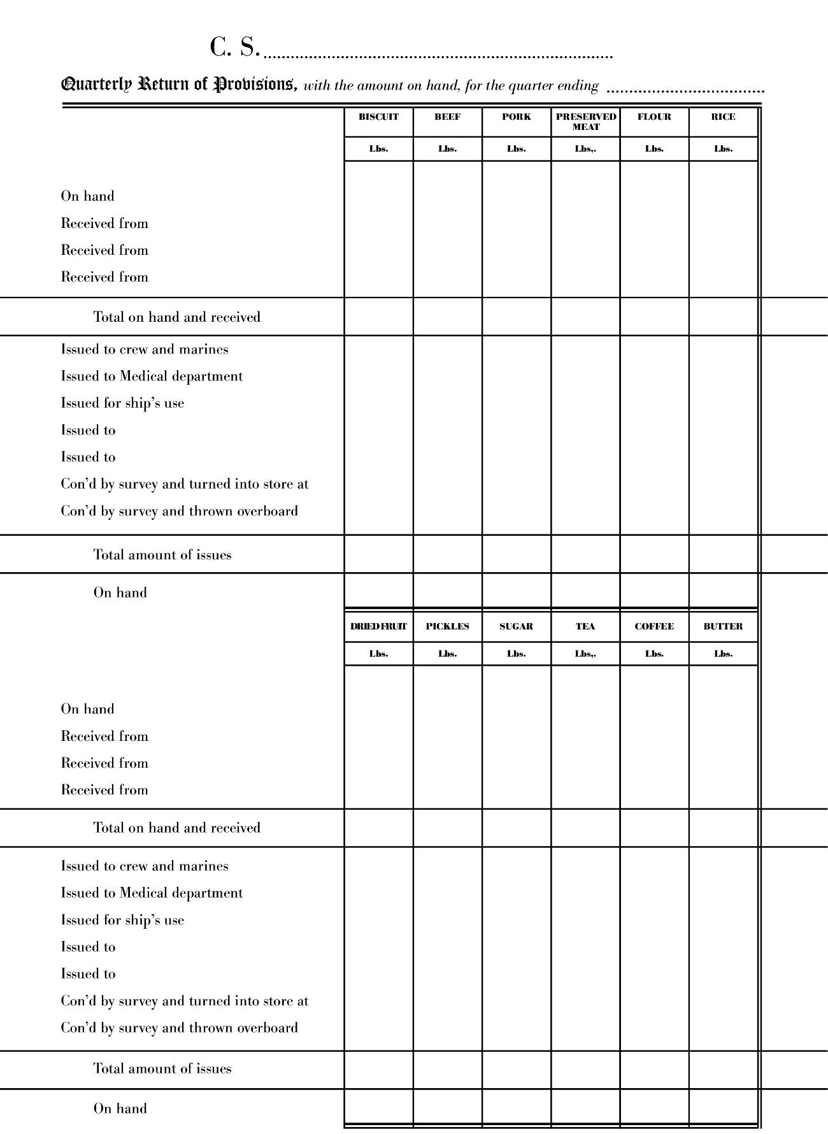

Quarterly return of provisions, CSN
Scale to 112%
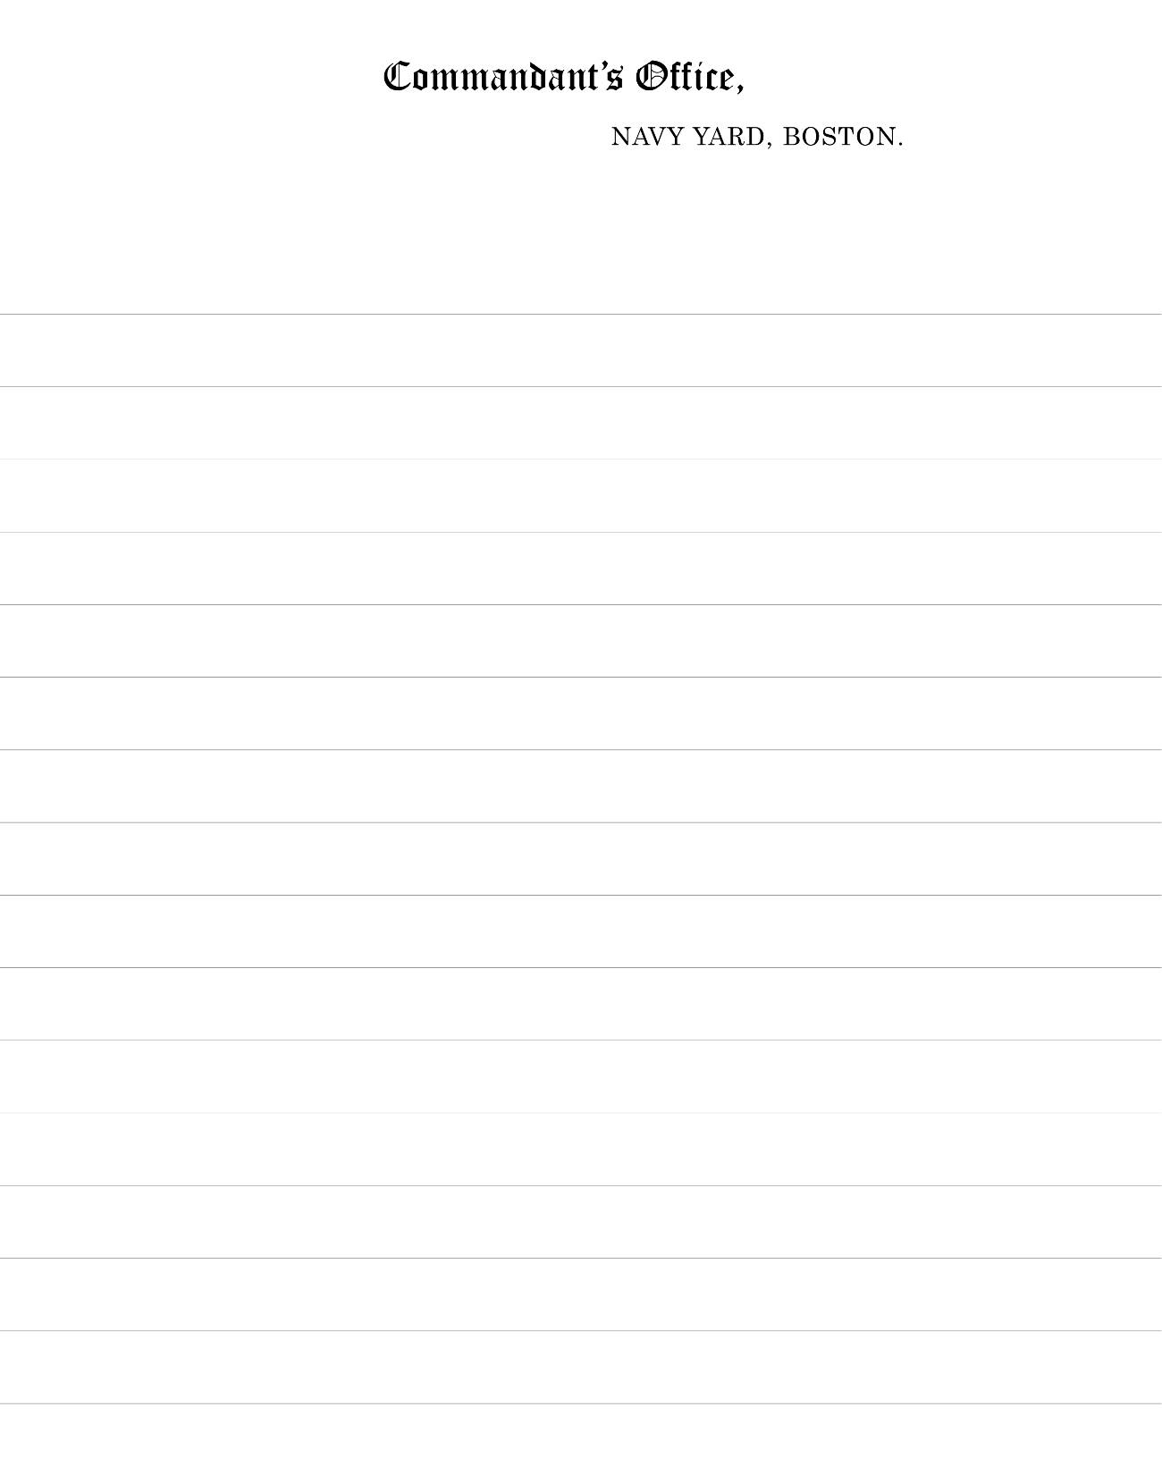

Notepaper, Commandant, Navy Yard, Boston
(based on NY Navy Yard original)
Scale to 120%
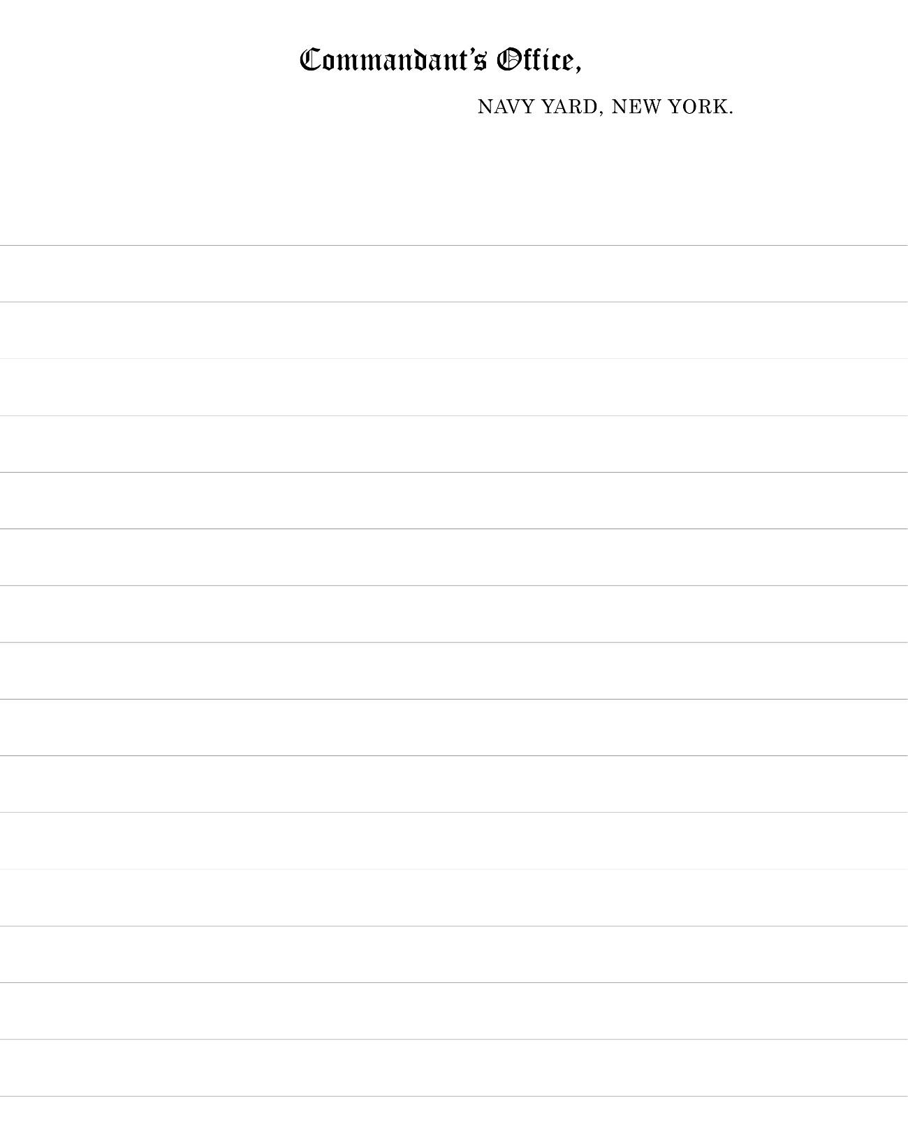

Notepaper, Commandant, Navy Yard, New York
Scale to 120%
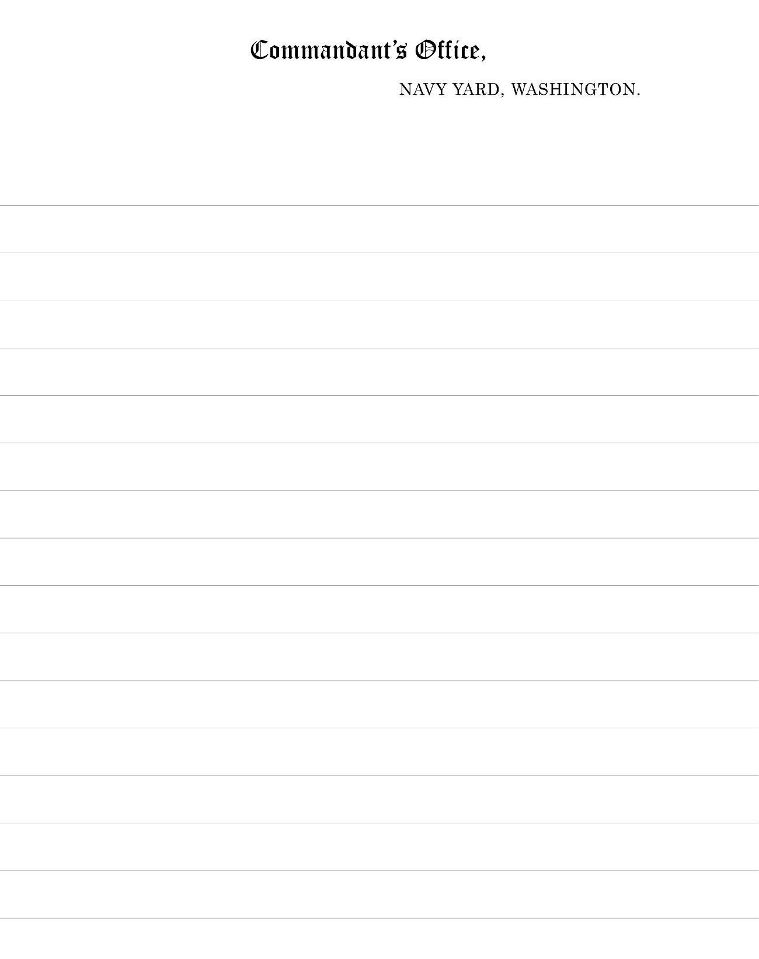

Notepaper, Commandant, Navy Yard, Washington
(based on NY Navy Yard original)
Scale to 120%
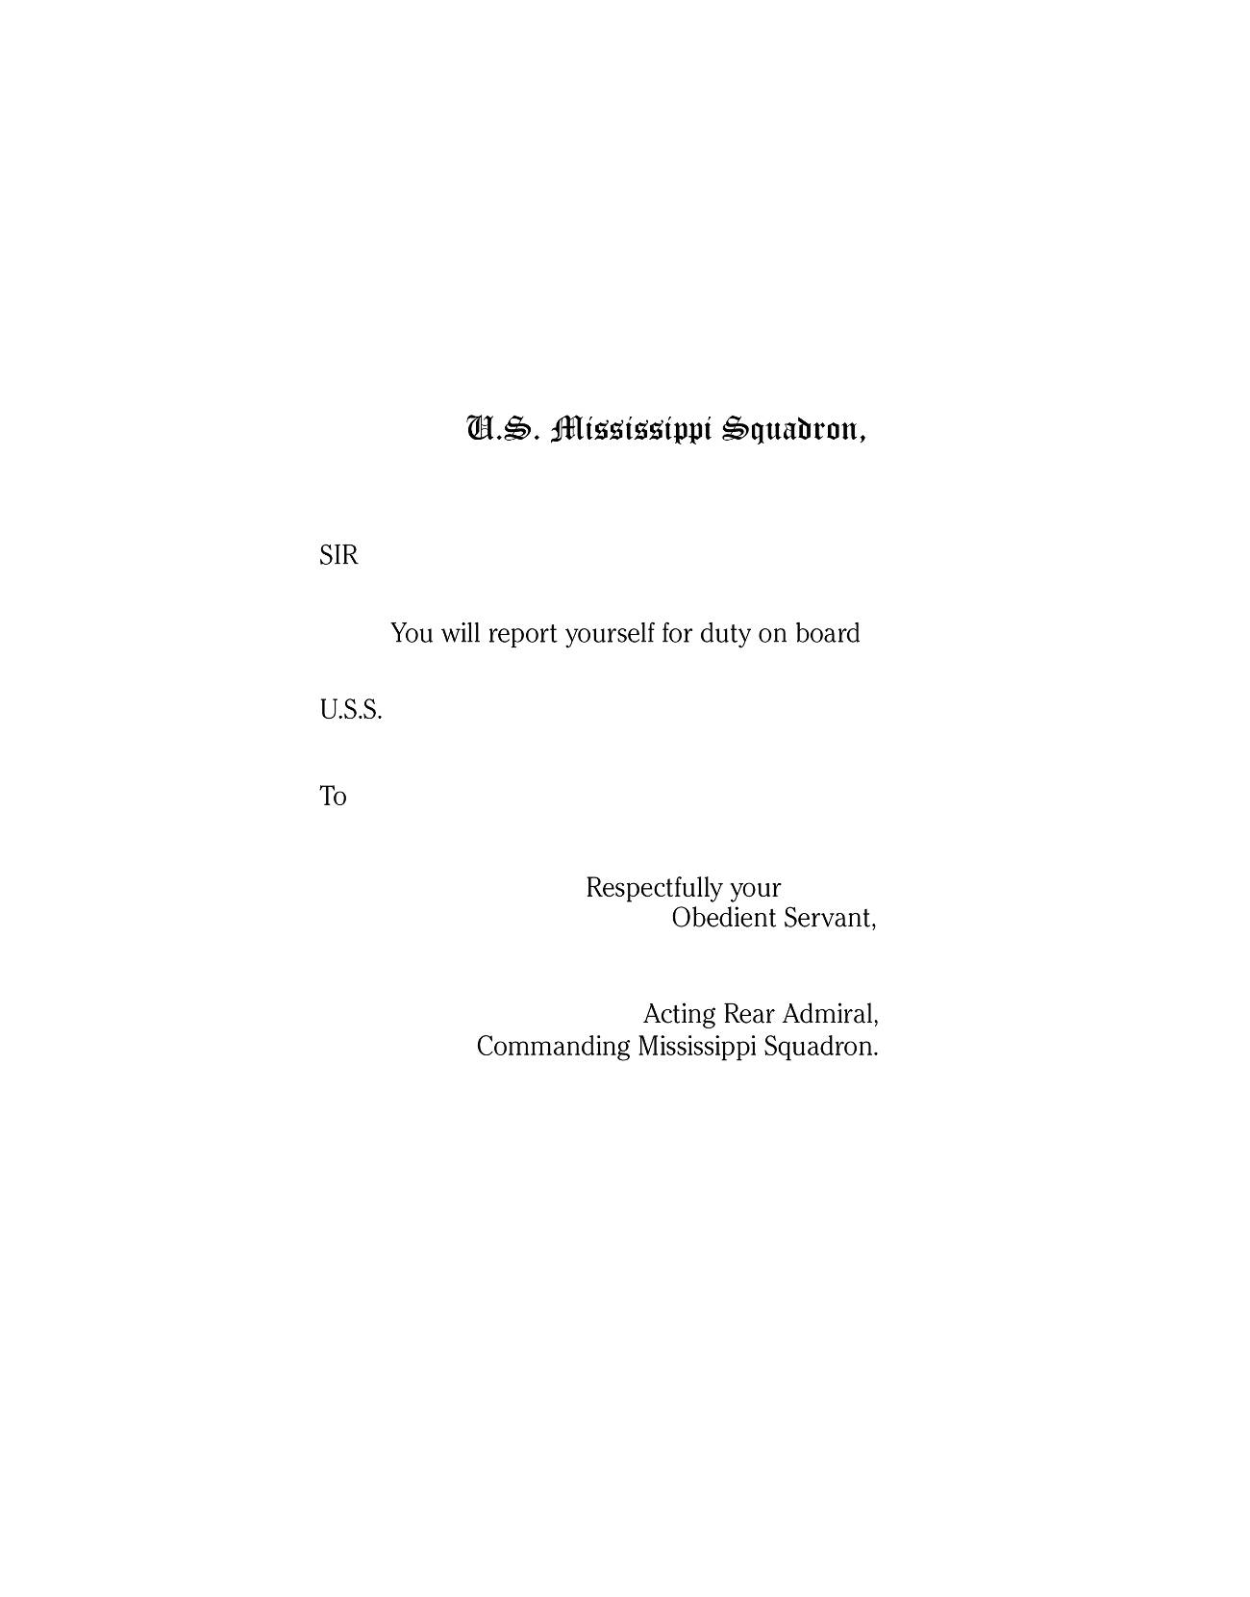

Order blank, Mississippi Squadron
(meant to be folded in thirds and addressed on the outside; see originals)
Scale to 120%
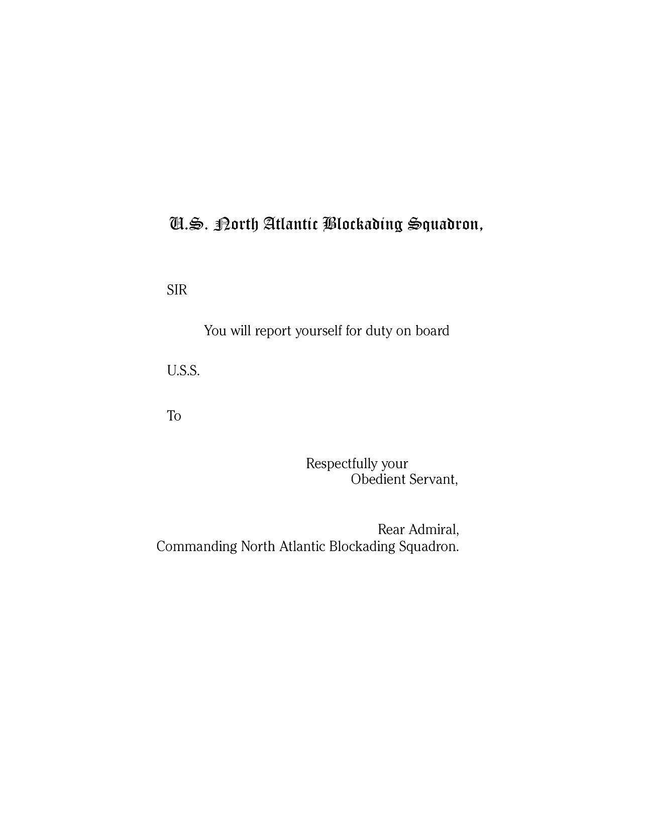

Order blank, North Atlantic Blockading Squadron
(based on Mississippi Squadron original)
(meant to be folded in thirds and addressed on the outside; see originals)
Scale to 120%
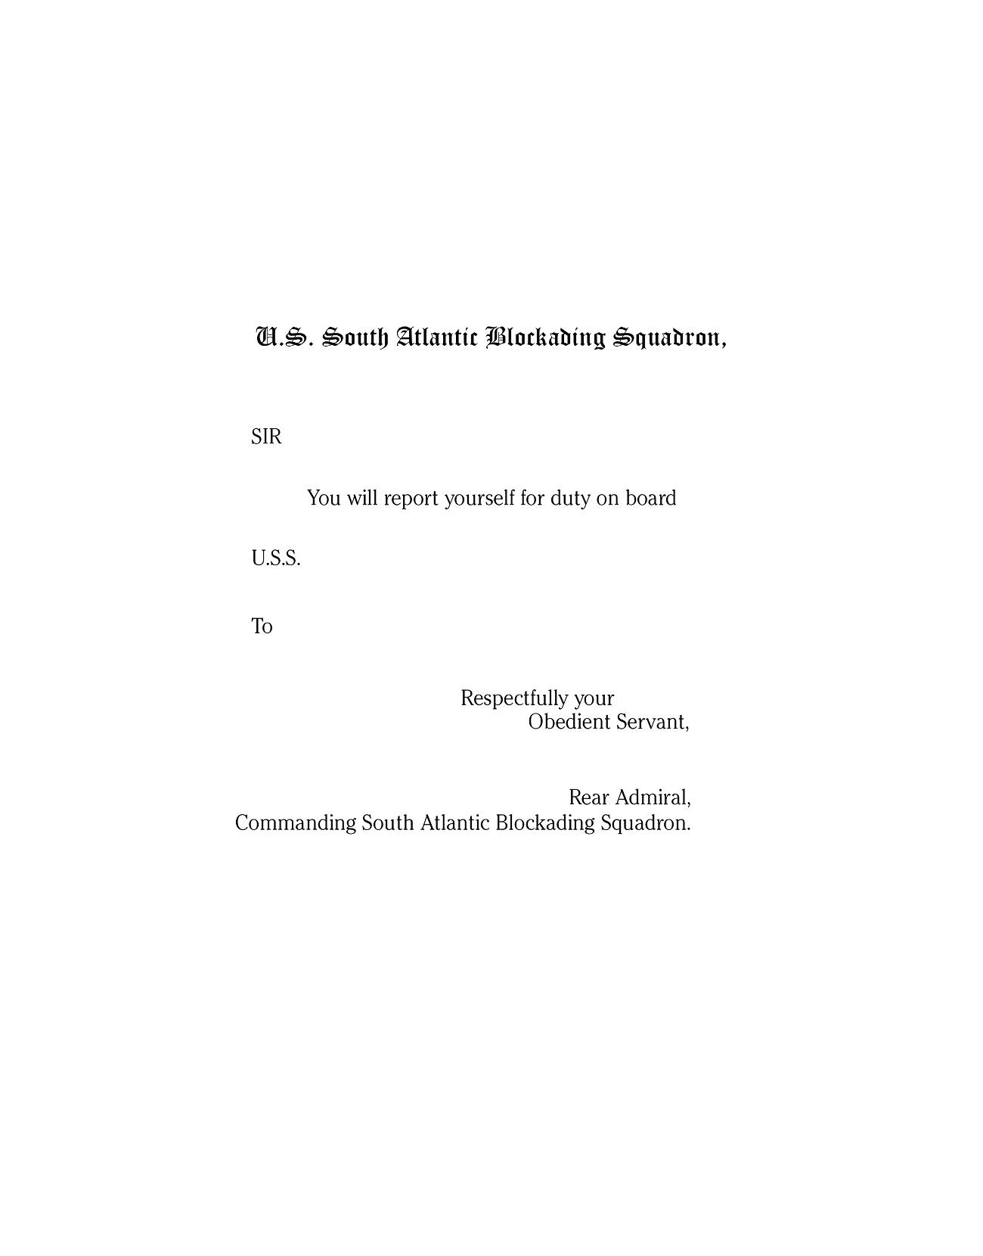

Order blank, South Atlantic Blockading Squadron
(based on Mississippi Squadron original)
(meant to be folded in thirds and addressed on the outside; see originals)
Scale to 120%
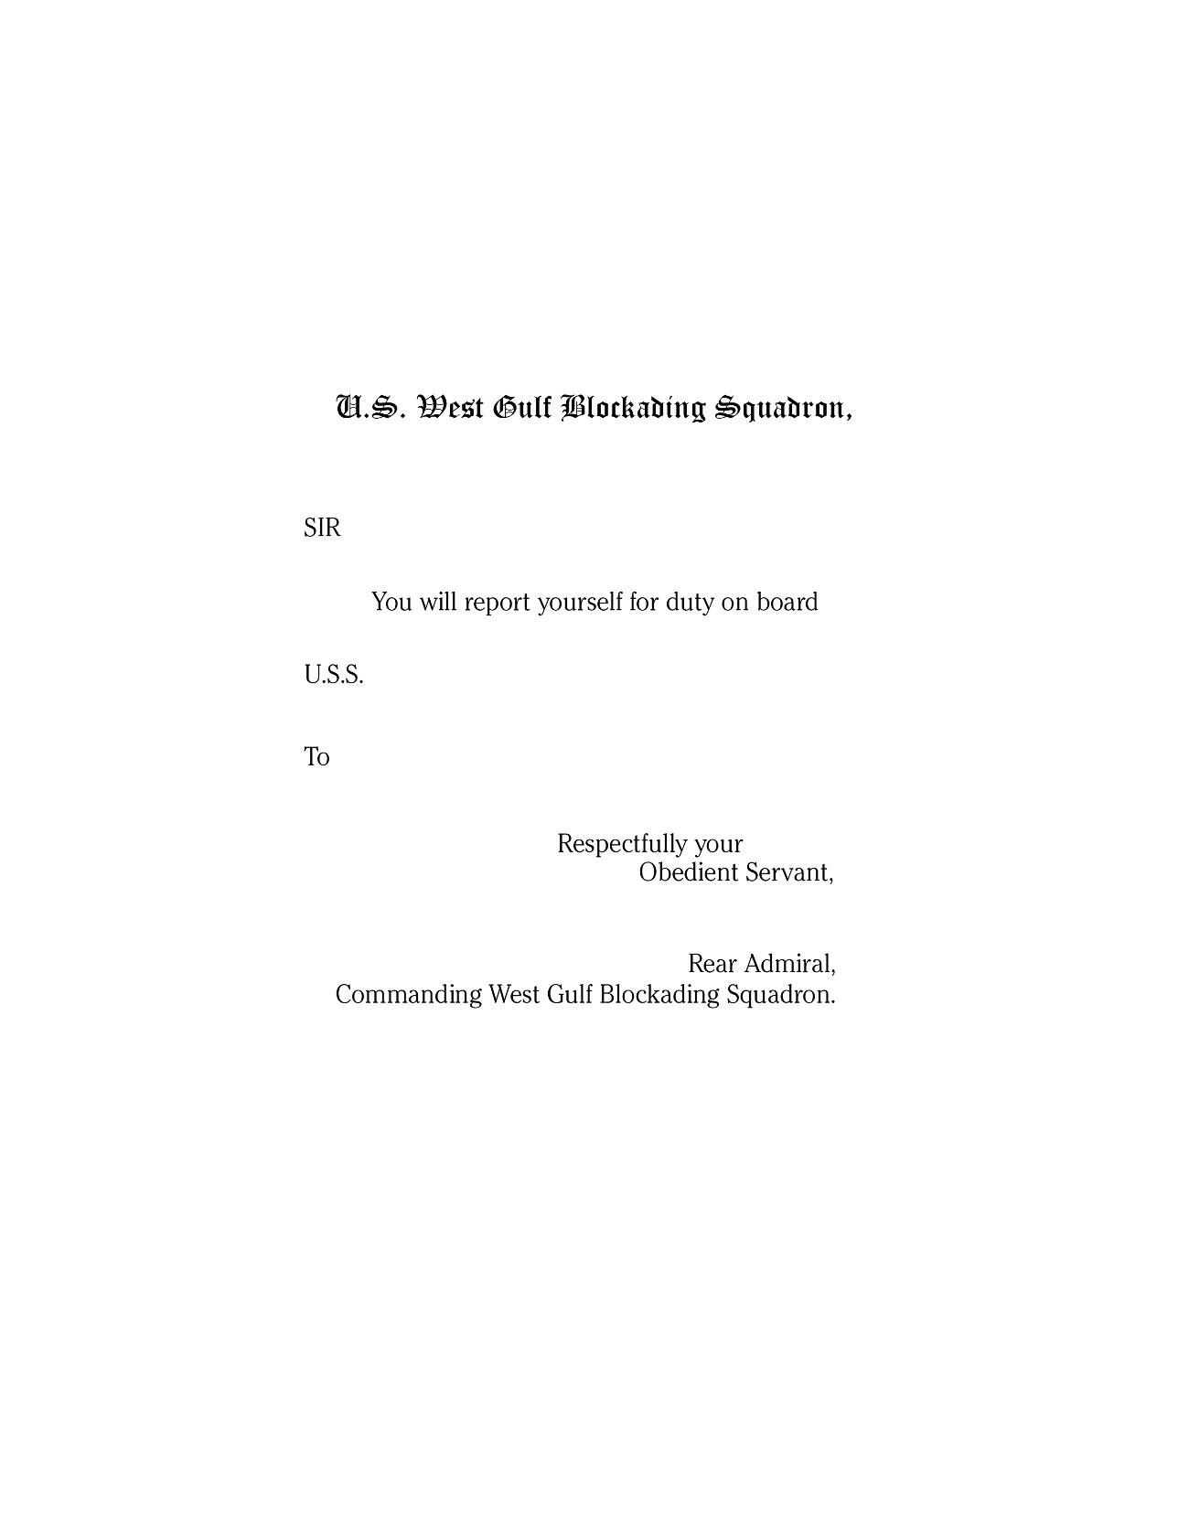

Order blank, West Gulf Blockading Squadron
(based on Mississippi Squadron original)
(meant to be folded in thirds and addressed on the outside; see originals)
Scale to 120%
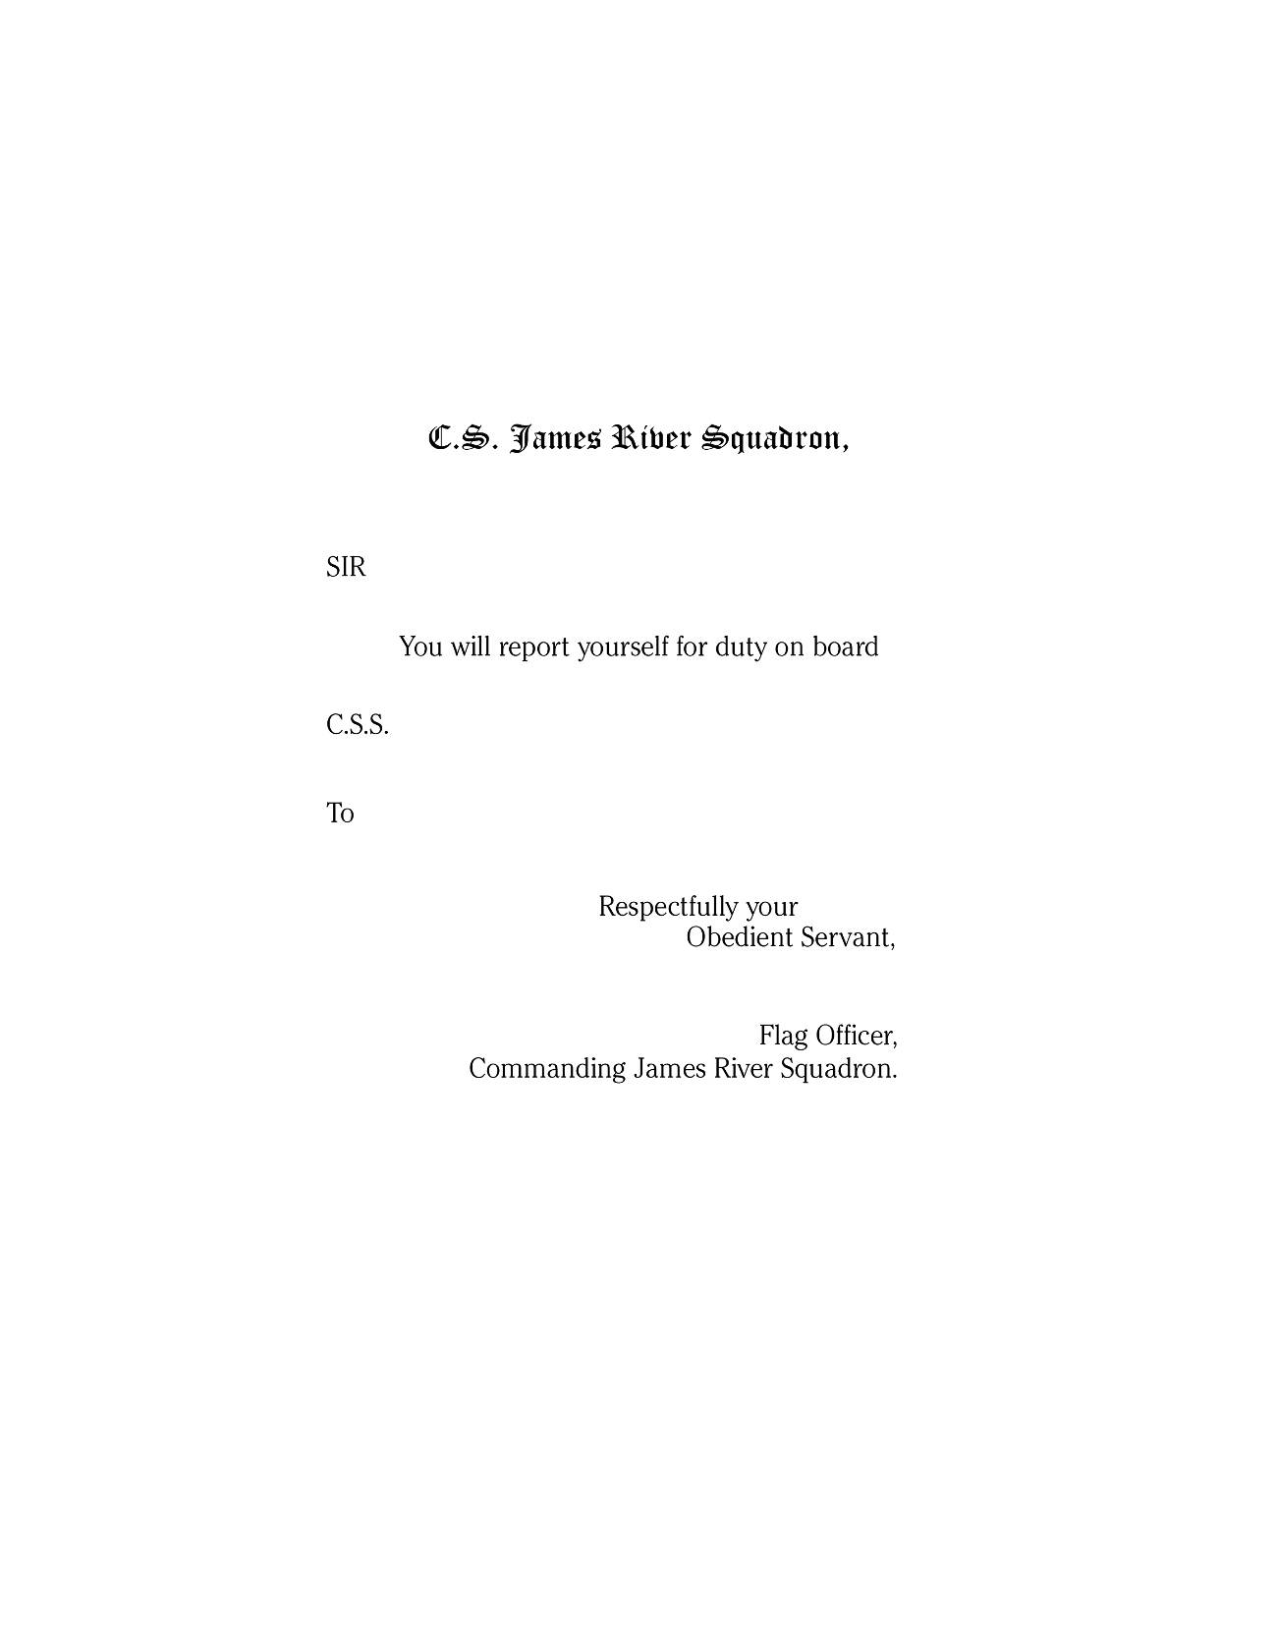

Order blank, James River Squadron
(based on USN Mississippi Squadron original)
(meant to be folded in thirds and addressed on the outside; see originals)
Scale to 120%
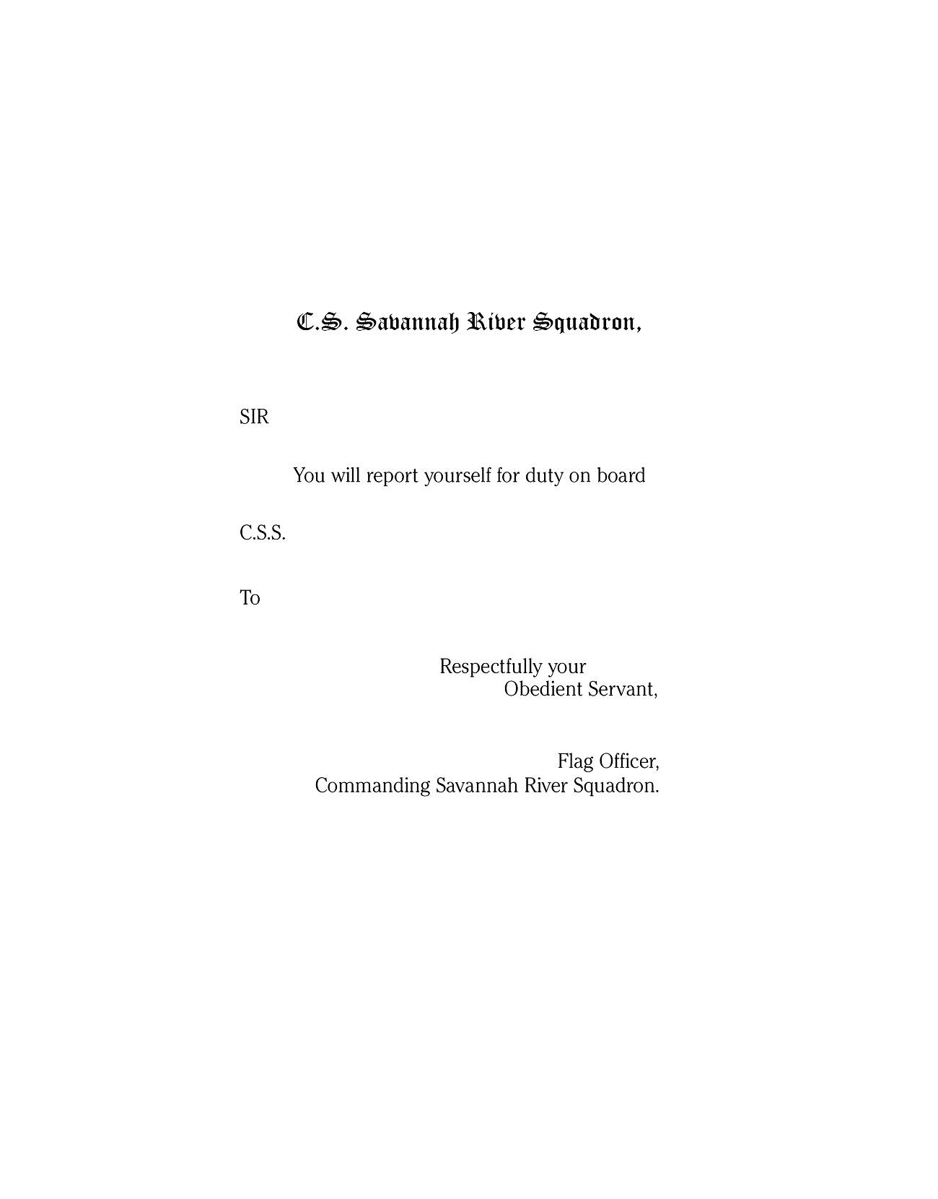

Order blank, Savannah River Squadron
(based on USN Mississippi Squadron original)
(meant to be folded in thirds and addressed on the outside; see originals)
Scale to 120%
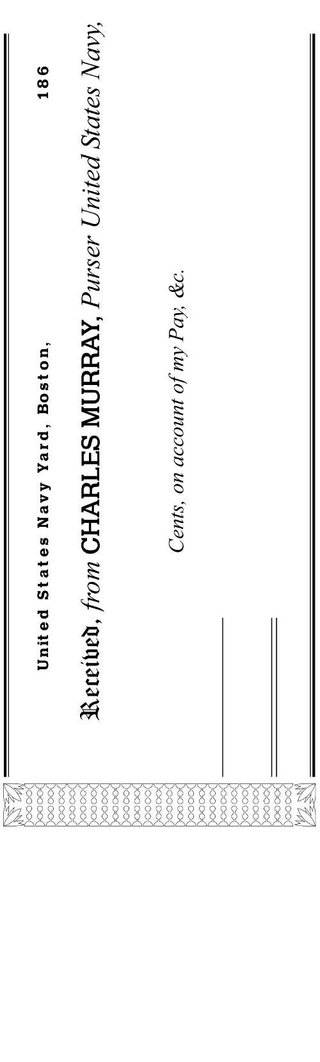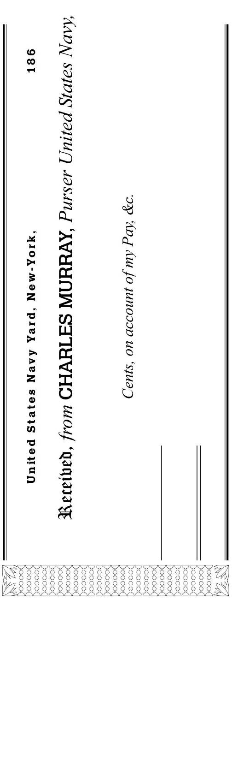

USN Pay receipts, actual size
(should be printed on light blue paper)
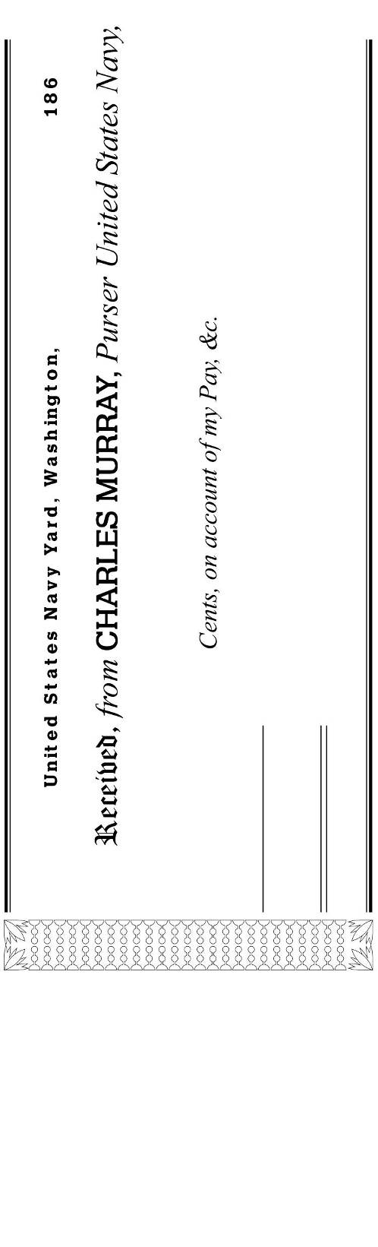

USN Pay receipt, actual size
(should be printed on light blue paper)
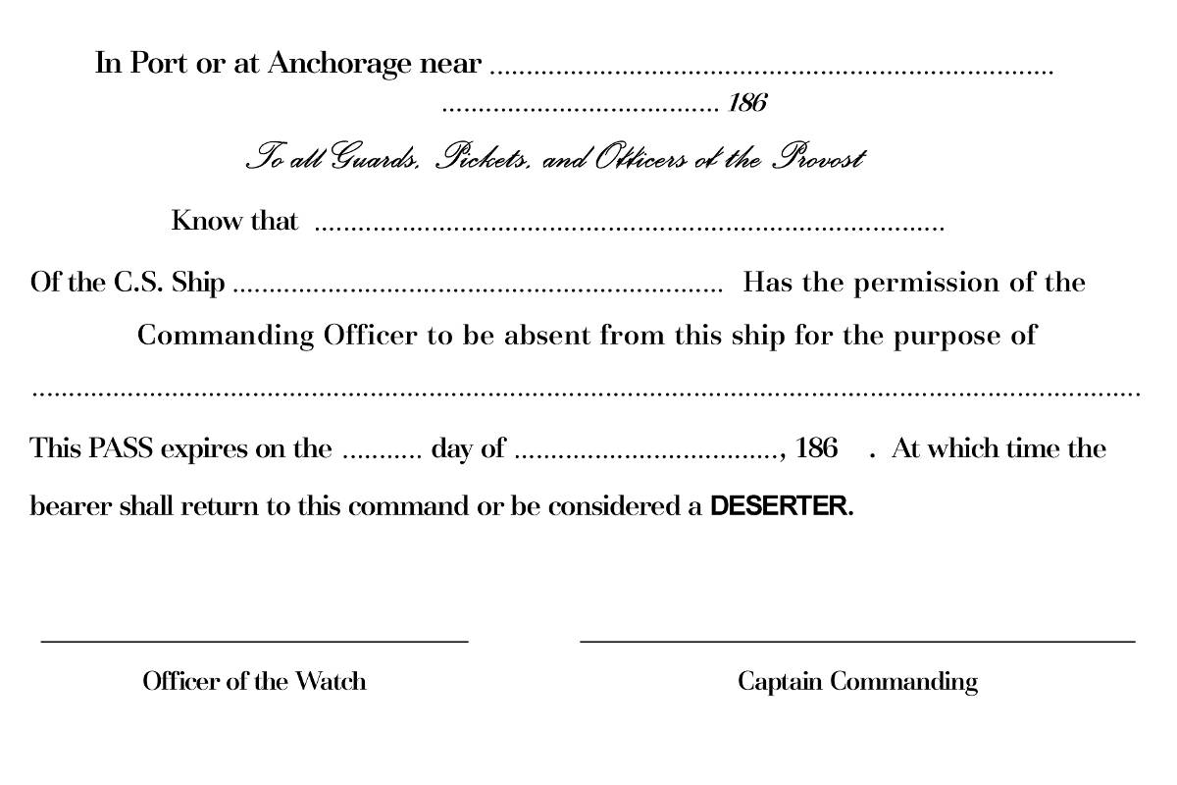

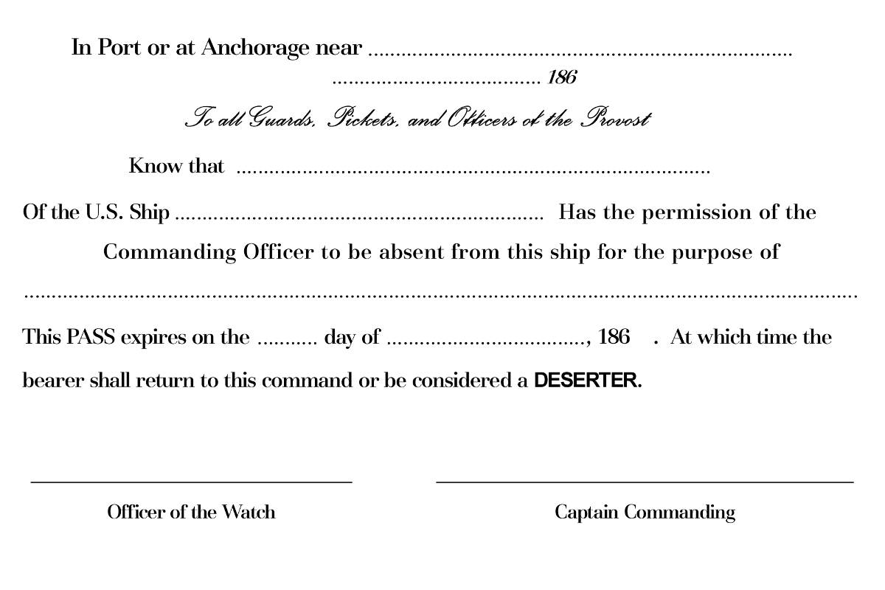

CSN and USN shore passes
Actual size, based on CSN original
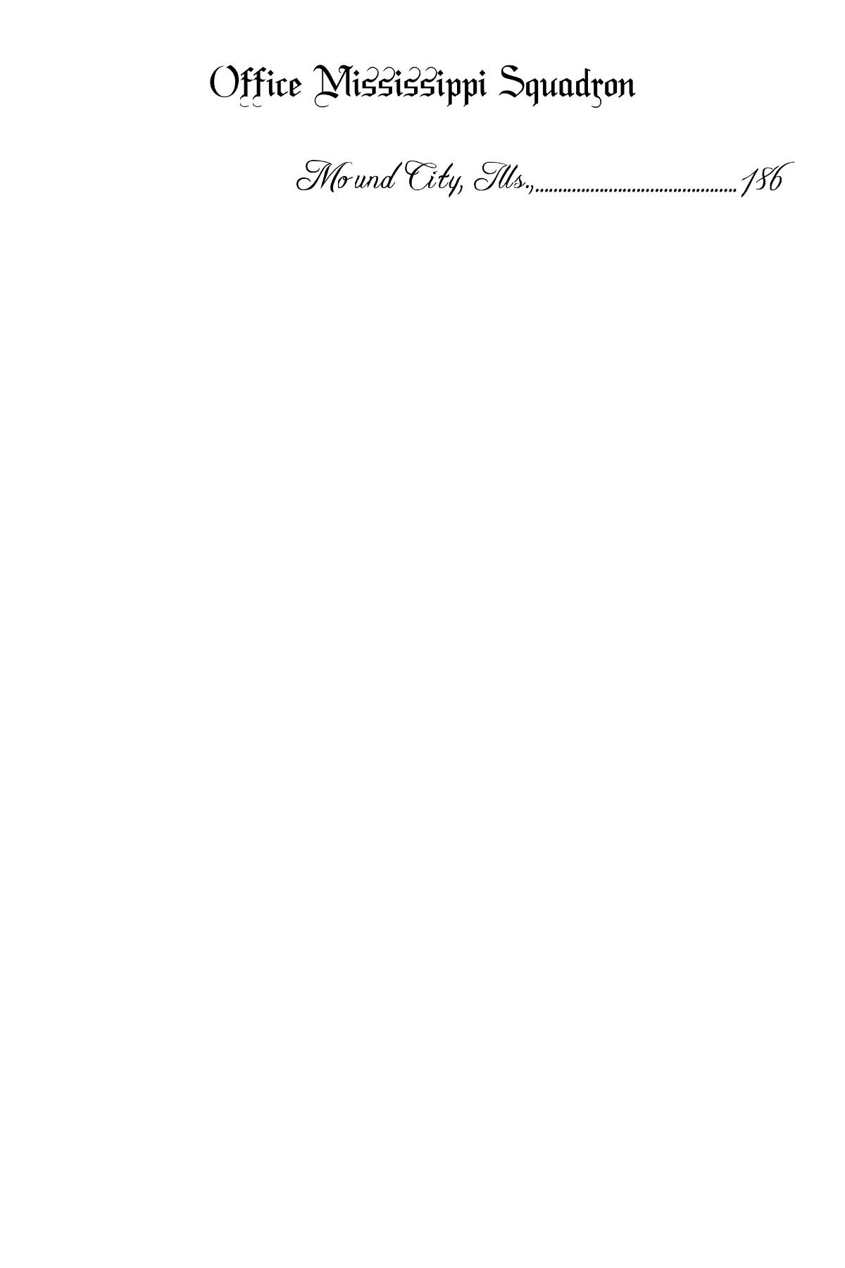

USN Mississippi Squadron letterhead, actual size
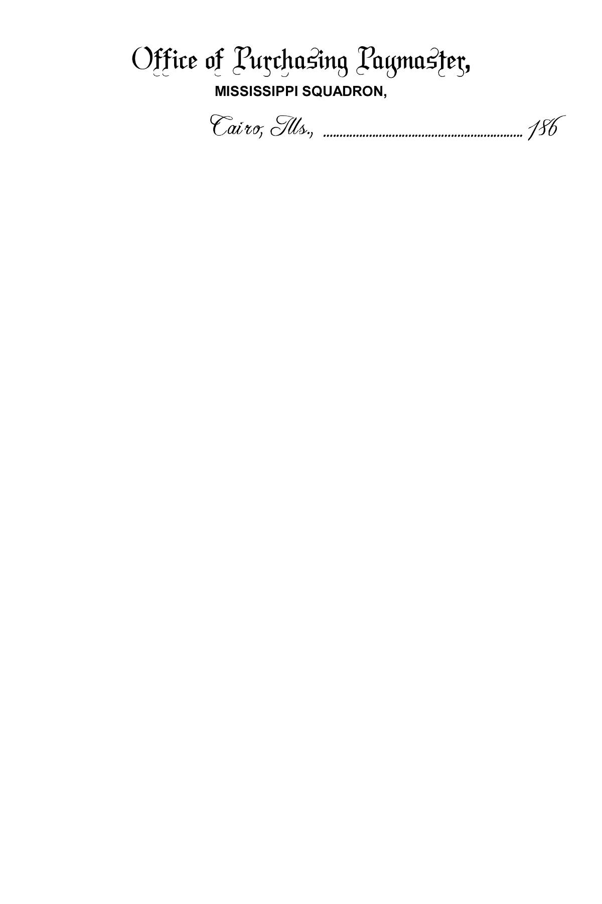

USN Mississippi Squadron Paymaster letterhead, actual size
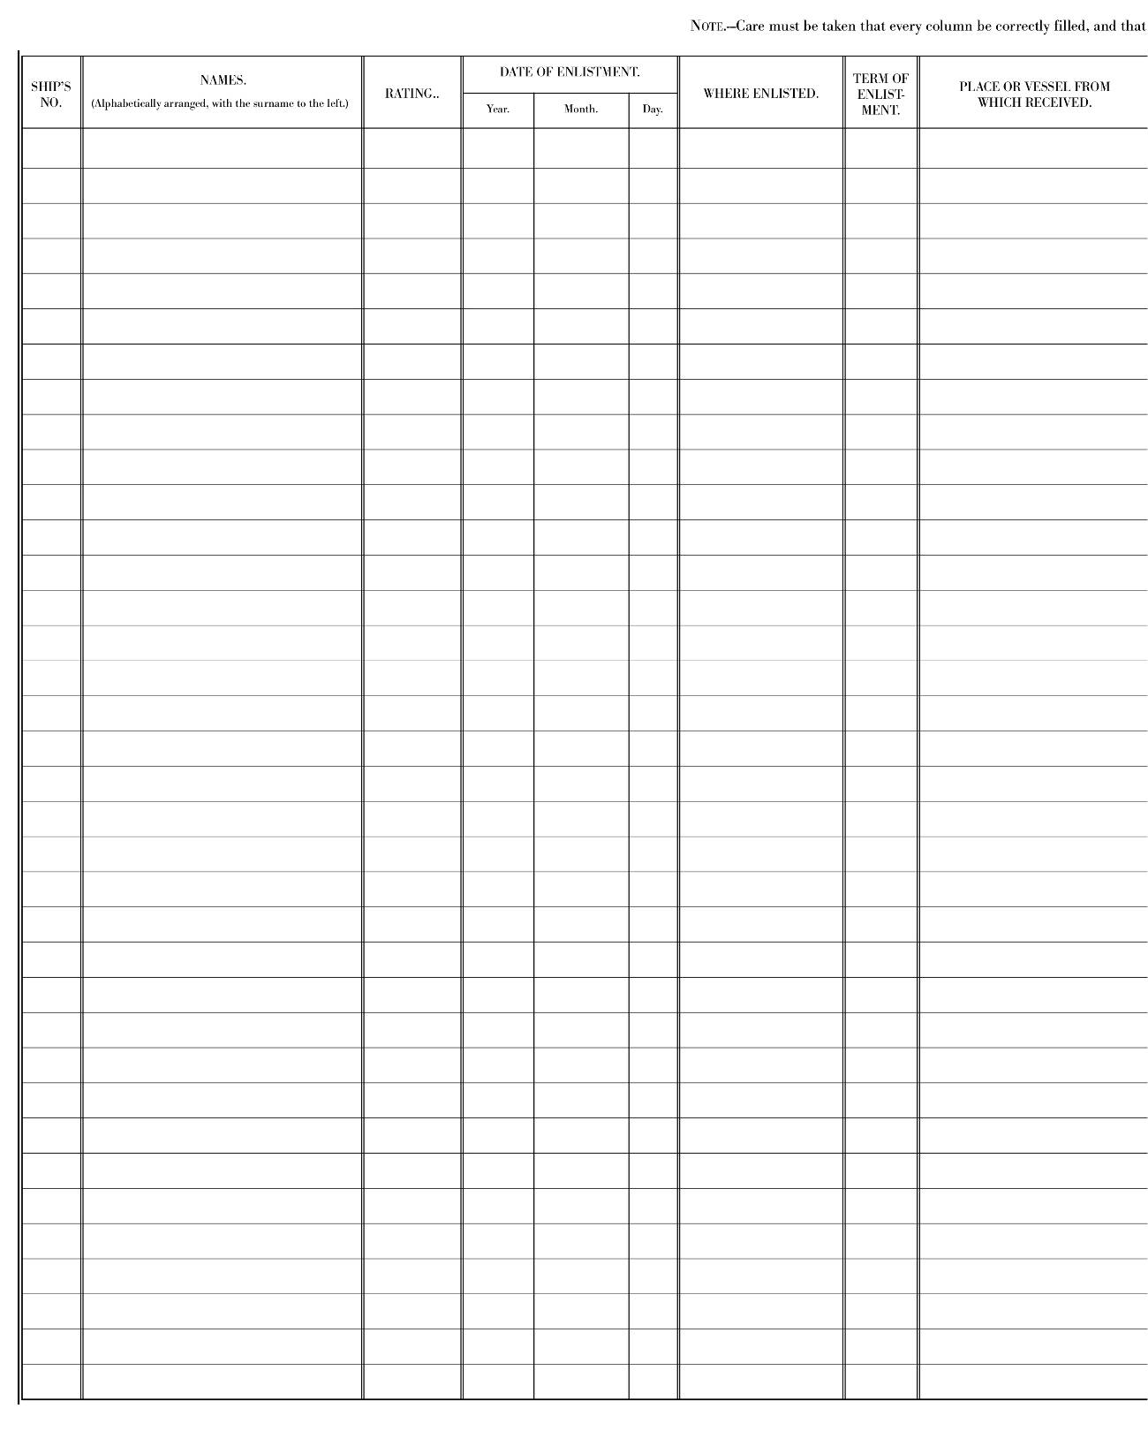

Muster form based on USN original
Left half; use this form when you expect to fill the page
Scale to 125% and print both halves on 11x17 sheet
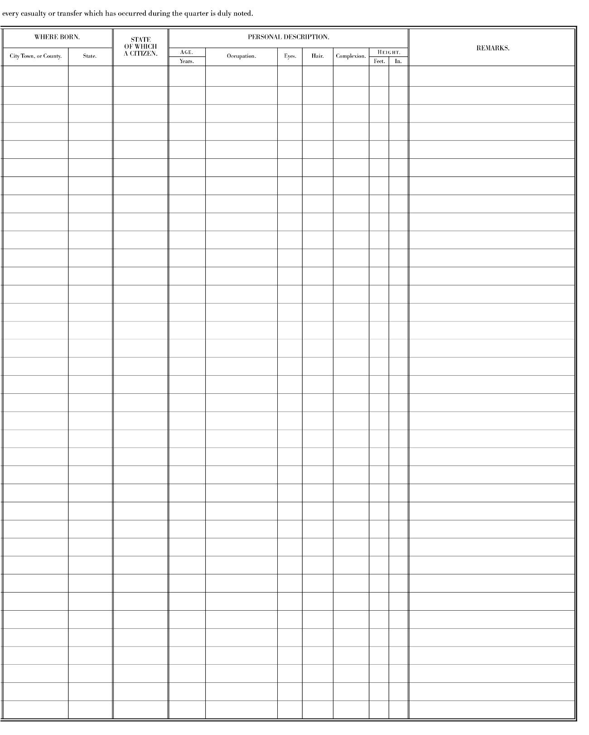

Muster form based on USN original
Right half; use this form when you expect to fill the page
Scale to 125% and print both halves on 11x17 sheet
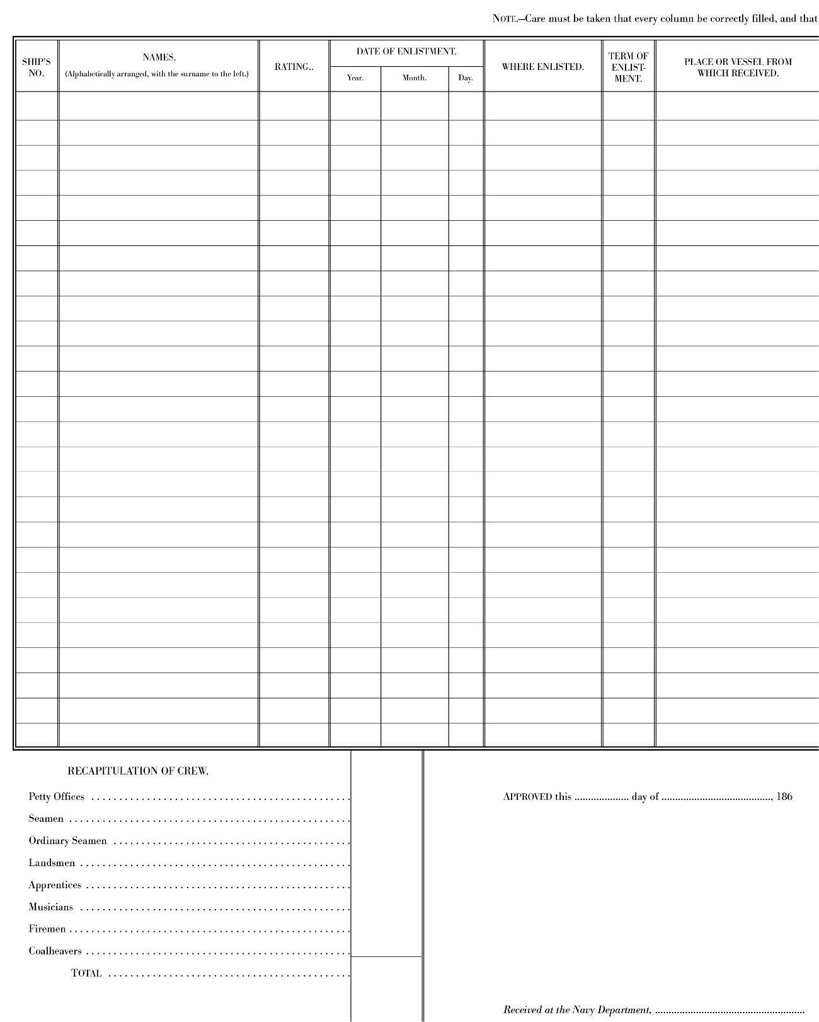

Muster form based on USN original
Left half; use this form as the final page in the return
Scale to 125% and print both halves on 11x17 sheet
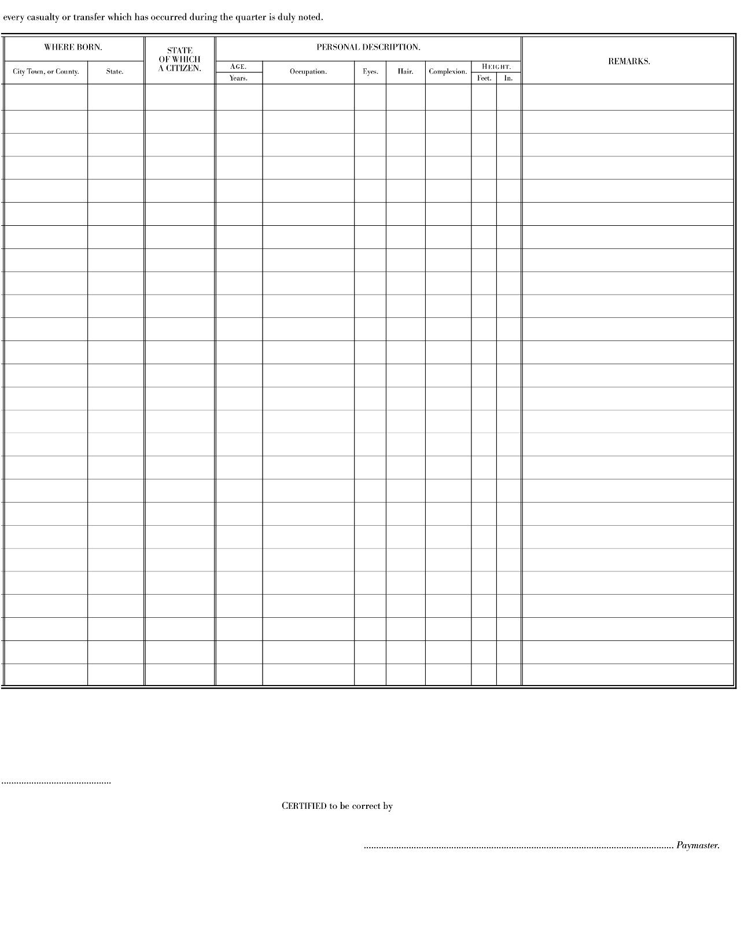

Muster form based on USN original
Right half; use this form as the final page in the return
Scale to 125% and print both halves on 11x17 sheet
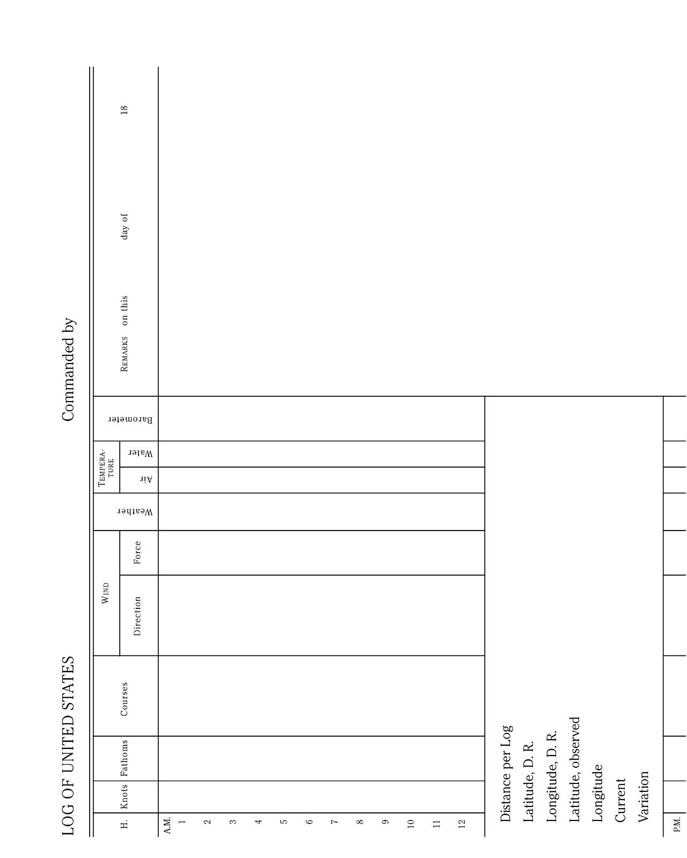

Deck log based on USN original
Top half
Scale to 125% and print both halves on 11x17 sheet
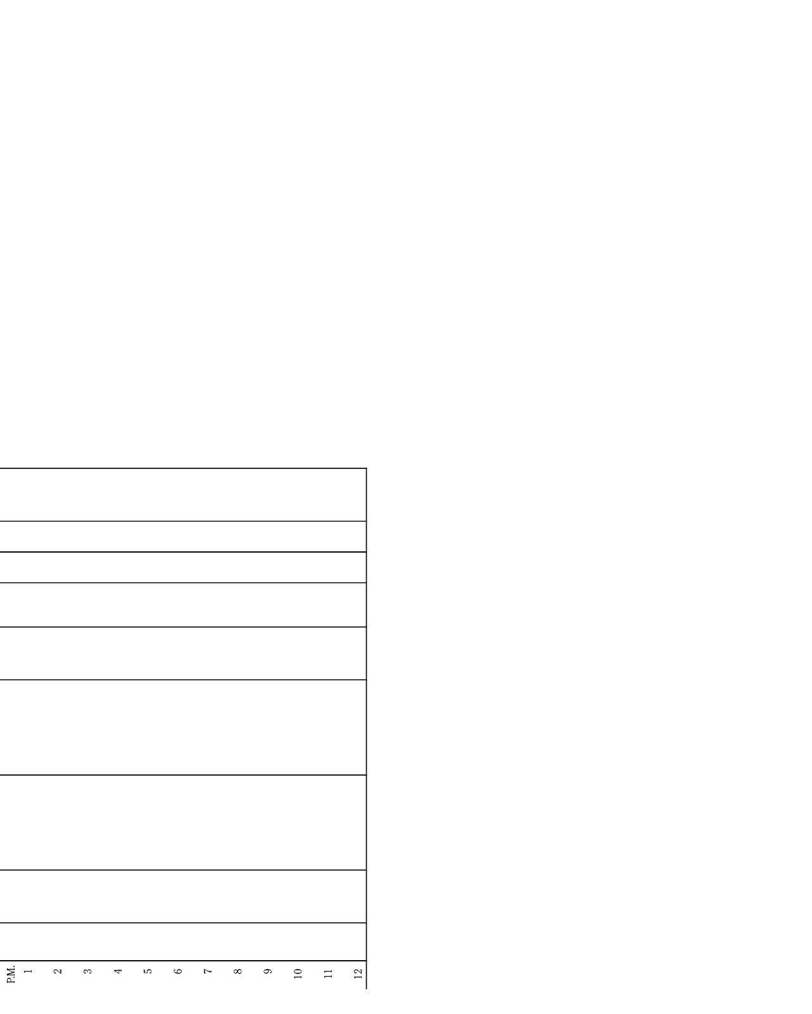

Deck log based on USN original
Lower half
Scale to 125% and print both halves on 11x17 sheet
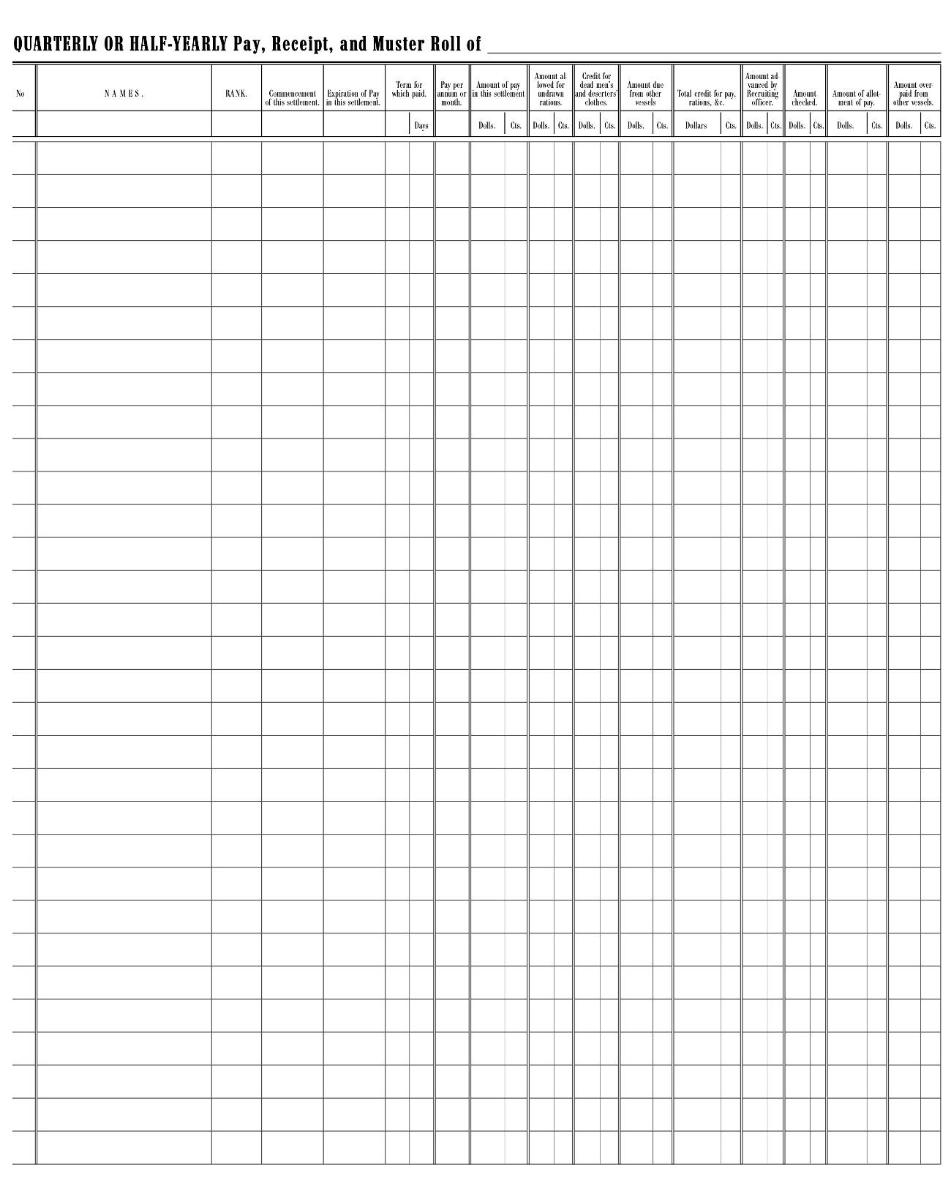

Quarterly return based on CSN original
Left half
Scale to 125% and print both halves on 11x17 sheet
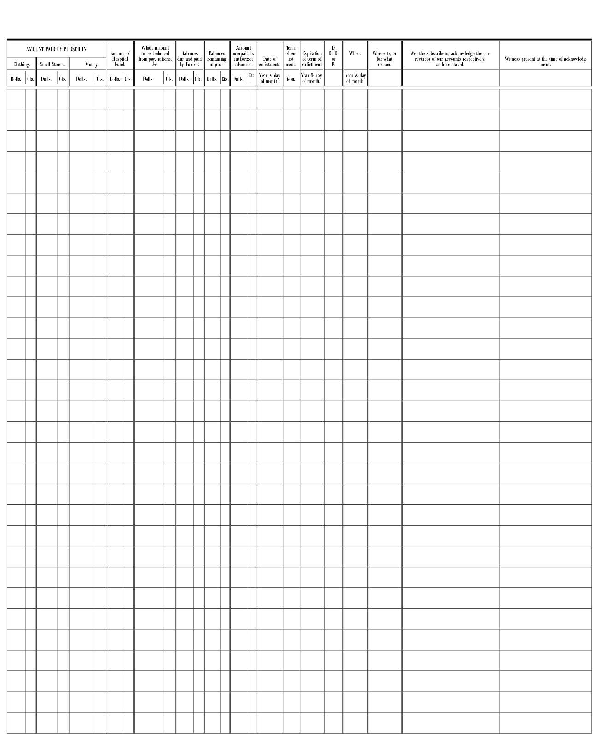

Quarterly return based on CSN original
Right half
Scale to 125% and print both halves on 11x17 sheet
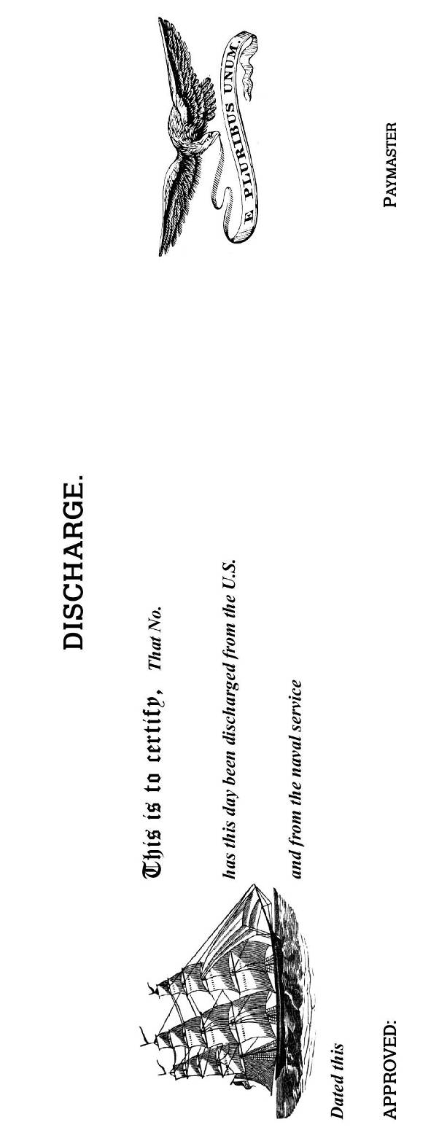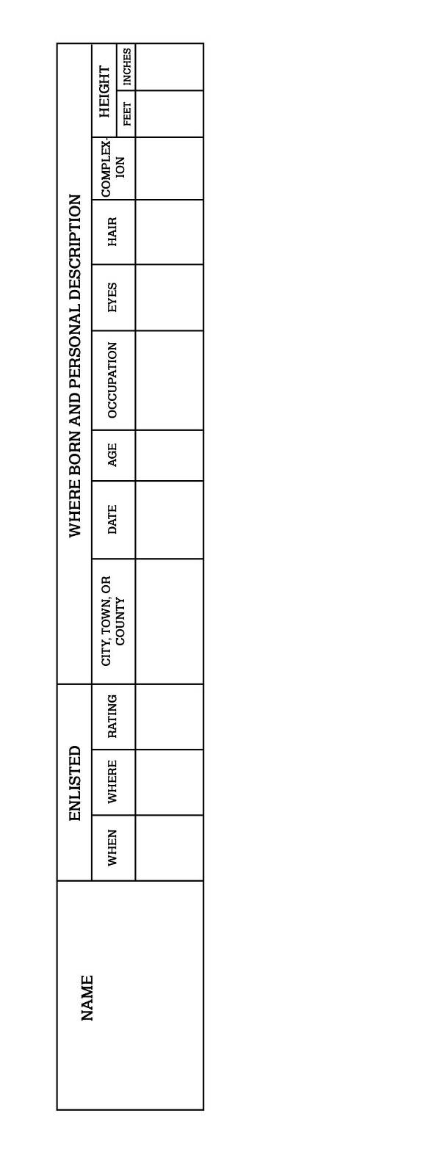

USN discharge form, actual size

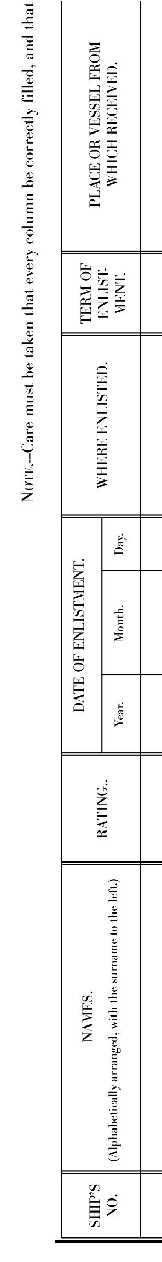 | 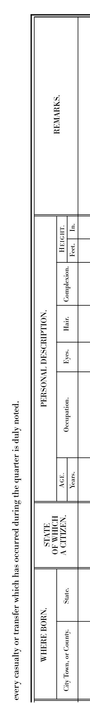 | 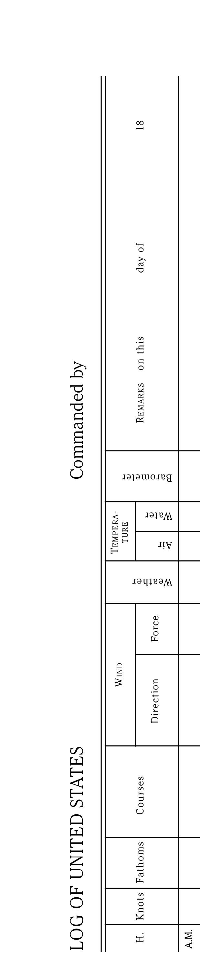 | 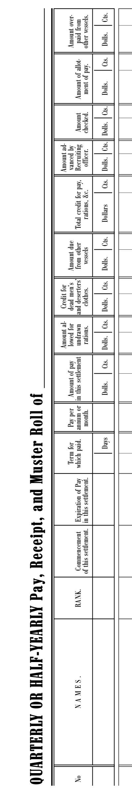 | 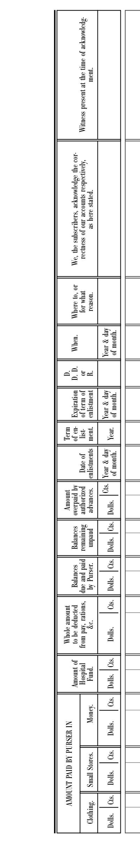

Headings for assorted forms, actual size

